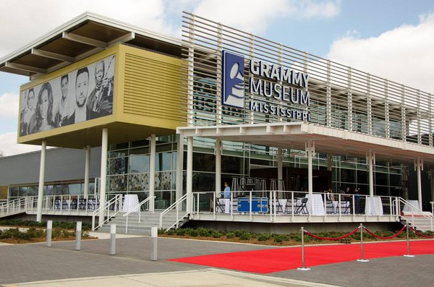

CEDS

2018 - 2022

COMPREHENSIVE ECONOMIC
DEVELOPMENT STRATEGY

South Delta Planning and Development
District, Inc.

COMPREHENSIVE ECONOMIC
DEVELOPMENT STRATEGY

FOR THE
SOUTH DELTA PLANNING AND DEVELOPMENT DISTRICT, INC.

COUNTIES

BOLIVAR SHARKEY
HUMPHREYS SUNFLOWER
ISSAQUENA WASHINGTON

September 2018

PREPARED BY
South Delta Planning and Development District, Inc.
1427 South Main Street, Suite 147, Greenville, MS 38702

The preparation of this report was made possible by a grant from the U. S. Department of
Commerce, Economic Development Administration.
Table of Contents
Introduction 5
Organization and Management 7
Regional Analysis 13
Population 13
Income and Education 17
Water 30
Sewer 32
Transportation 32
Industrial Parks and Sites 35
Water Resources 36
Natural 37
Political 37
Economic 38
Social 39
Resiliency 39
SWOT Analysis 41
Strengths 41
Weaknesses 41
Opportunities 42
Threats 42
Goals and Objectives 43
STRATEGIC PROJECTS, PROGRAMS AND ACTIVITIES 45
ACTION PLAN 52
PERFORMANCE MEASURES 53

Introduction
The South Delta Planning and Development District, Inc. was incorporated under State Law as a non-profit corporation on September 8, 1967. In January 1976, the Charter was changed and the organization is currently a non-profit, non-taxable corporation as designated by The Internal Revenue Code 501 (C) (3). In 1971, the Governor of the State of Mississippi changed the name from Economic Development District, to Planning and Development District, and delineated its boundaries.
The South Delta Planning and Development District, Inc. serves Bolivar, Sunflower, Washington, Humphreys, Sharkey and Issaquena counties as well as the 35 municipalities within these six counties. The region served has a land area of 3,602 square miles and an estimated population (July1, 2017) of 118,263.
South Delta assists local governments with economic development efforts, workforce, housing, community development, childcare and programs for the elderly. The District serves as the Regional Clearinghouse Coordinator, the Delta Workforce Investment Opportunity Area administrator, the Area Agency on Aging and the U. S. Census Data Affiliate.
This Comprehensive Economic Development Strategy (CEDS) has been developed through a cooperative effort between citizens, local elected officials, CEDS Committee members and District personnel. Through surveys, meetings, research and observations this document provides an overview of the District as a whole and the individual factors involved in development of the area. The CEDS is to be the basis for district-wide planning and implementation activities for the next five years. However, this document, the analysis and the ideas within are not static. This plan will be revisited numerous times over the next five years and, with the assistance of each local government and the CEDS committee, the plans, goals and objectives will be amended as necessary to reflect changes in the area.
This document includes broad goals and objectives of the region along with some of the readily identifiable needs of the area and potential actions to address these needs. those needs. It also includes an analysis of the strengths, weaknesses, opportunities and threats of the region. Apparent in recent years is the need for useable regional planning documents to include information related to the resilience of the area with regard to natural disasters and a method of evaluating successes and failures. This document includes both.
The completed CEDS will be made available to the public for review and comment. The CEDS will be available at the offices of South Delta Planning and Development as well as on the South Delta website. The document will be provided to State and Federal agencies for integration into state and regional economic development efforts.

Organization and Management

INTRODUCTION
The South Delta Planning and Development District, Inc. was incorporated under State Law as a non-profit corporation on September 8, 1967. In January 1976, the Charter was changed and the organization is currently a non-profit, non-taxable corporation as designated by the Internal Revenue Code 501 (C) (3). In 1971, the Governor of the State of Mississippi changed the name from Economic Development District, to Planning and Development District, and delineated its boundaries.
BOARD OF DIRECTORS
South Delta Planning and Development District is governed by county and municipal governments through their selection of representatives to the Board of Directors. At the fall meeting of the District, the second of two open meetings held each year, election of Board members is carried out. Each county makes nominations from within their county and members are voted on by the full Board.
There are 25 directors serving staggered three-year terms. The Board, in accordance with 13 CFR 304.2 (c)(2) and the Amended Bylaws of South Delta Planning and Development District, Inc., is broadly representative of the principal economic interests of the Region, capable of implementing the relevant Comprehensive Economic Development Strategy (CEDS) and, unless otherwise prohibited by applicable State or local law, includes at least one Private Sector Representative per county and/or Executive Directors of Chambers of Commerce, or representatives of institutions of post-secondary education, workforce development groups or labor groups. The District’s governing body shall have at least a simple majority its membership who are elected officials. The number of directors from each county varies depending on the population of the county. The three largest counties have five directors and the smallest counties each have three. There is one at-large Director, a member of the Mississippi Legislature from the six-county region. The current Board of Directors is listed on the following page.

Board Member | County | Representing
Will Hooker | Bolivar | County Administrator
Billy Nowell | Bolivar | Elected Official - Mayor
Henry Phillips, Jr. | Bolivar | Private Sector - Restaurant
Bern Prewitt | Bolivar | Private Sector – Agricultural Aviation
Judson Thigpen, II | Bolivar | Chamber of Commerce
Willie F. Brown | Humphreys | Private Sector - Farming
Henry Reed, Jr. | Humphreys | Private Sector – Home Health
Richard D. Stevens | Humphreys | Elected Official – County Supervisor
William Carpenter | Issaquena | Private Sector
Michael Parker, Sr. | Issaquena | Elected Official - Alderman
Eddie Holcomb, III | Issaquena | Elected Official – County Supervisor
Willie Smith | Sharkey | Elected Official – County Supervisor
Merlin Richardson | Sharkey | Private Sector - Retired
Russell Stewart | Sharkey | Private Sector - Bank
Barry Bryant | Sunflower | Private Sector – Automobile Sales
Clanton Beamon | Sunflower | Private Sector - Retired
Edgar Donahoe | Sunflower | Private Sector - Retired
Dennis W. Holmes, Sr. | Sunflower | Elected Official – County Supervisor
Steve Shurden | Sunflower | Executive Director Sunflower County EDD
Helen Johnson | Washington | City Clerk
Mike Gordon | Washington | Private Sector – Retired
Marilyn Hansell | Washington | Elected Official - Chancery Clerk
Cora Burnside | Washington | Elected Official - Mayor
Kenny Thomas | Washington | Elected Official - Mayor
Willie Simmons | At-Large | Elected Official – Mississippi Legislature

At the first board meeting following the District’s annual meeting, officers of the corporation are selected by the Board of Directors. The President of the Board then appoints an executive committee of not more than nine members. There will be two executive committee members from each of the three largest counties and one member from each of the three smallest counties. The executive committee, also serving as the loan committee, meets once a month. The full board meets a minimum of once per year. Two meetings, open and advertised to the public are held each year, one in the spring and one in the fall. The spring public meeting provides an opportunity to present to the general public an overview of the District’s activities of the previous year. The fall meeting includes election of new Board members and provides an opportunity for discussion of plans for the upcoming year.
MEMBER GOVERNMENTS
South Delta Planning and Development District is made up of six counties and the thirty-five municipalities within those counties.
Bolivar County | Humphreys County | Issaquena County
Alligator | Belzoni | Mayersville
Benoit | Isola | Sunflower County
Beulah | Louise | Doddsville
Boyle | Silver City | Drew
Cleveland | Sharkey County | Indianola
Duncan | Anguilla | Inverness
Gunnison | Cary | Moorhead
Merigold | Rolling Fork | Ruleville
Mound Bayou |  | Sunflower
Pace | Washington County
Renova | Arcola
Rosedale | Greenville
Shaw | Hollandale
Shelby | Leland
Winstonville | Metcalfe

CEDS COMMITTEE
The 2017 CEDS Committee is much larger, with a broader cross-section of the region’s economic interest than in the past. These committee members were brought together by the District and volunteered their input for the future of the region based on the roles they currently and/or previously played within the community.

The CEDS committee is as follows:

Henry Perkins | Bolivar County | Elected Official – Mayor - Winstonville
Carey Estes | Bolivar County | Elected Official – Mayor - Rosedale
Barbara Humphrey | Bolivar County | Workforce Development
Cathy Dickerson | Bolivar County | Medicaid Waiver* - Nurse
Michele Reed | Bolivar County | Medicaid Waiver – LSW** - Case Manager
Tommie Brown | Bolivar County | Elected Official – Mayor - Alligator
Eunice Sanders | Bolivar County | Private Sector
Peggy Mengarelli | Bolivar County | Elected Official – Mayor - Shelby
Evereth Stanton | Bolivar County | Elected Official – Mayor - Shaw
Judson Thigpen | Bolivar County | Chamber/Industrial Development
Will Hooker | Bolivar County | County Administrator
Bern Prewitt | Bolivar County | Private Sector - Agriculture
Bobbie Reed | Bolivar County | Elected Official – Alderwoman - Shelby
Henry Phillips | Bolivar County | Private Sector – Restaurant – Retired Educator
Jana Meyer | Bolivar County | Medicaid Waiver – LSW – Case Manager
Wanda Ledford | Bolivar County | Medicaid Waiver - Nurse
Eddie Hall | Bolivar County | Medicaid Waiver - Nurse
Lisa Houston | Bolivar County | Medicaid Waiver - Nurse
Frances Flowers | Humphreys County | Private Sector
Woodrow Johnson | Humphreys County | Elected Official – County Supervisor
Henry Reed | Humphreys County | Private Sector – Home Health
Jerry Wood | Humphreys County | Elected Official – County Supervisor
James Bankhead | Humphreys County | Elected Official – County Supervisor
Carol Ivy | Humphreys County | Elected Official – Mayor – Belzoni
Ruffin Smith | Humphreys County | Elected Official – Mayor – Louise
Linda Short | Issaquena County | Elected Official – Mayor – Mayersville
William Carpenter | Issaquena County | Private Sector
William Holcomb, III | Issaquena County | Elected Official – County Supervisor
Charles Weissinger | Issaquena County | Attorney
Michael Parker, Jr. | Issaquena County | Elected Official – County Supervisor
Marcus Hooker, Jr. | Sharkey County | Engineer
Sandra Nichols | Sharkey County | City Clerk – Rolling Fork
Merlin Richardson | Sharkey County | Private Sector – Retired - Agriculture
LaDonna Sias | Sharkey County | Elected Official – Alderwoman – Rolling Fork
Russell Stewart | Sharkey County | Private Sector – Banking/Workforce/Elected
Andrew Smith | Sunflower County | City Manager
Jane McCarty | Sunflower County | Medicaid Waiver - Nurse
Cheryl Beck | Sunflower County | Medicaid Waiver – LSW – Case Manager
Penne Davis | Sunflower County | Medicaid Waiver – LSW – Case Manager
Vescia Smith | Sunflower County | Medicaid Waiver - Nurse
Riley Rice | Sunflower County | Elected Official – County Supervisor
Clanton Beamon | Sunflower County | Private Sector – Retired – Non-Profit
Richard Noble | Sunflower County | Attorney
Patricia Plummer | Sunflower County | Medicaid Waiver – Nurse
Steve Shurden | Sunflower County | County Economic Development District
Dennis Holmes | Sunflower County | Elected Official – County Supervisor
George Holland | Sunflower County | Elected Official – Mayor - Moorhead
Kenny Thomas | Washington County | Elected Official – Mayor - Leland
Carolyn Baker | Washington County | Economic Alliance
Debra Wintory | Washington County | Greenville Chamber of Commerce
Blythe Hamburg | Washington County | Medicaid Waiver – LSW – Case Manager
Amanda Watson | Washington County | Medicaid Waiver – Nurse
Brittany Stone | Washington County | Medicaid Waiver – LSW – Case Manager
Robin Williams | Washington County | Medicaid Waiver – Nurse
Sylvia Jackson | Washington County | Area Agency on Aging
Tracy Malone | Washington County | Medicaid Waiver – Supervisor
Ruby Moody | Washington County | Medicaid Waiver – LSW – Case Manager
Angela Carter | Washington County | Mississippi Access to Care
Kamesa Sibley | Washington County | Area Agency on Aging
Thressa Love | Washington County | Medicaid Waiver – LSW – Case Manager
Clara Martin | Washington County | Medicaid Waiver – LSW – Case Manager
Jennifer Price | Washington County | Go Greenville – College Student
Mike Gordon | Washington County | Private Sector – Retired Food Sales
Cora Burnside | Washington County | Elected Official – Mayor - Arcola
Sponjetta Sims | Washington County | Mississippi Access to Care
Mitzi Woods | At-Large | Workforce Development
Mike Philpot | At-Large | Delta Council
Chuck Herring | At-Large | Small Business Development
*Medicaid Waiver – Employed by South Delta Planning
**LSW – Licensed Social Worker

During the CEDS committee development process it became apparent that along with private sector representatives and elected officials the people that saw all of the region and communicated with the most citizens on a daily basis were the Medicaid waiver teams. These teams as well as the other CEDS committee members provide insight into the issues facing the region as they relate to growth and development. The CEDS committee brings with it knowledge of a broad range of topics from health care to education and from private business ownership to public policy. All of the areas of knowledge represented by the committee are vital to the future development of the South Delta region.

Regional Analysis

South Delta Planning and Development District includes 41 units of local government. Six counties and thirty-five municipalities make up that number. The counties served by the District are Bolivar, Humphreys, Issaquena, Sharkey, Sunflower and Washington. The regional analysis section of this document serves to give insight into the traits and characteristics that make up the area known as South Delta. Population and demographics, clusters, infrastructure, financial resources and external forces will be looked at from a regional standpoint as well as on a county-by-county basis.

POPULATION AND DEMOGRAPHICS

Population

South Delta is comprised of 3,602 square miles of land area. That equates to approximately 8% of Mississippi’s land area. Based on U. S. Census Bureau 2017 Population Estimates, there are 118,263 people living in the South Delta region. This is only 3.9% of the estimated 2017 Mississippi population. The population of the District, between 2000 and 2010, decreased by 17.47% while the population of the State increased. The District population has shown another decrease of 6.9% between 2010 and 2016.
South Delta Planning and Development District experienced a total population decline of 44.28% from 1960 to 2017. The majority of the District’s population resides in three of the six counties. These three counties – Bolivar, Sunflower and Washington – have over 88% of the population. Going hand in hand with this is the fact that the majority of the civilian labor force resides in and is employed in these three counties. Residents of the three smaller counties, the three southern counties of the District, must obtain employment from the limited opportunities in each county. Those unable to find employment within their own county must commute to the surrounding areas.

POPULATION TRENDS PERCENT CHANGE, 1960 - 2017
 | 1960 | % CHANGE | 1970 | % CHANGE | 1980 | % CHANGE | 1990 | % CHANGE
South Delta PDD | 212,259 | -13.6 | 183,312 | -3.1 | 177,561 | -7.8 | 163,786 | -3.5
Mississippi (000) | 2,178 | 1.8 | 2,217 | 13.7 | 2,520 | 2.1 | 2,573 | 10.5
Counties
Bolivar | 54,464 | -9.3 | 49,409 | -7 | 45,965 | -8.9 | 41,875 | -3
Humphreys | 19,093 | -23.5 | 14,601 | -4.6 | 13,931 | -12.9 | 12,134 | -7.6
Issaquena | 3,576 | -23.5 | 2,737 | -8.2 | 2,513 | -24 | 1,909 | 19.1
Sharkey | 10,738 | -16.8 | 8,937 | -10.9 | 7,964 | -11.3 | 7,066 | -6.9
Sunflower | 45,750 | -19 | 37,047 | -5.9 | 34,844 | -5.6 | 32,867 | -4.6
Washington | 78,638 | -10.2 | 70,581 | 2.5 | 72,344 | -6.1 | 67,935 | -7.3
 | 2000 | % CHANGE | 2010 | % CHANGE | 2017E
South Delta PDD | 158,039 | -17.5 | 130,429 | -9.3 | 118,263
Mississippi (000) | 2,844 | 4.3 | 2,967 | 0.6 | 2,984
Counties
Bolivar | 40,633 | -15.9 | 34,145 | -6.4 | 31,945
Humphreys | 11,206 | -16.3 | 9,375 | -11 | 8,342
Issaquena | 2,274 | -38.2 | 1,406 | -4.8 | 1,339
Sharkey | 6,580 | -25.3 | 4,916 | -9.8 | 4,435
Sunflower | 34,369 | -14.3 | 29,450 | -11.8 | 25,981
Washington | 62,977 | -18.8 | 51,137 | -9.6 | 46,221
 | E = Estimate
SOURCE:
U. S. Census of Population, General Population Characteristics, Mississippi 1960-2000.
U. S. Census Bureau, Census 2010.
U. S. Census Bureau, 2017 Estimates.

Generally, it can be stated that there are certain predominant population, labor force, income and educational trends in the South Delta District that have existed in past years and are still present in varying degrees today. In the past, the District’s economy was based solely on agriculture. With the advent of mechanized farming, the need for laborers who possessed very little education and few job skills was diminished drastically. Laborers were forced to seek employment elsewhere, usually in the industrialized cities of the North. In 2017, just as in 2007 and 2012, the District can be described as an economically depressed area experiencing a continuing decline in population due to out-migration and death; unemployment rates that are high; median family incomes that are extremely low; numbers of persons living below the poverty level are high and educational levels that are below standard.
The population of the District has declined by approximately 93,996 persons between 1960 and 2017. While all counties in the District have experienced significant population losses during the past several decades, Issaquena County has experienced the greatest loss in percentage of population. Issaquena County lost 62.56% of its population during the period 1960-2017, while Humphreys County followed closely with a population of loss of 58.70%. In terms of absolute numbers, Washington County lost the greatest amount of population during the same period amounting to over 32,000 persons.
A continuing decline of the population in the South Delta District can be attributed to out-migration. During the period from 1990-99 there were 26,767 births in the District. Between 2010 and 2017 the number of births in the District had decreased by 51.5% to 12,981. The number of deaths in the District,10,557, during the same period, 2010 – 2017, resulted in a natural increase of 2,424. Despite the fact that births in the District outnumber deaths, overall population continues to decline. Out migration continues to outnumber the natural increase in population occurring from births and deaths at a rate of approximately 4 to 1.
Based on 2016 U. S. Census American Community Survey Data, the District’s median age is 36 years while Mississippi’s is 36.7 and the United States’ 37.7. The District’s median age in 1960 was 19.9 years indicating the District’s population is becoming somewhat older. Of the District’s population in 2016, 35.8% were 0-24 years old while 13.4% were 65 years of age or older. This left 50.8% of the District’s population in the productive working age group of 25-64.

2016 POPULATION BREAKDOWN BY AGE GROUP
 | Preschool | School Age | College Age | Young Adult | Older Adult | Older
Bolivar County | 2,438 | 6,007 | 3,826 | 8,429 | 8,195 | 4,720
Humphreys County | 623 | 1,804 | 816 | 2,026 | 2,313 | 1,240
Issaquena County | 94 | 114 | 90 | 436 | 366 | 252
Sharkey County | 265 | 905 | 440 | 1,058 | 1,294 | 700
Sunflower County | 1,718 | 4,731 | 3,119 | 7,760 | 6,909 | 3,187
Washington County | 3,766 | 9,234 | 4,702 | 11,584 | 12,884 | 6,654
South Delta PDD | 8,904 | 22,795 | 12,993 | 31,293 | 31,961 | 16,753
Percent of District | 7.14% | 18.28% | 10.42% | 25.09% | 25.63% | 13.43%
Total District Population | 124,699
U. S. Census Bureau, American Community Survey
Preschool: 0-4; School Age: 5-17; College Age: 18-24; Young Adult: 25-44; Older Adult: 45-64; Older: 65 Plus

Generally, over the last decade, people have migrated outside the bounds of the District. From 2000-2010 the District’s urban population decreased 15.56% and the rural population decreased by 22.11%. The District’s loss in population is escalating and no longer limited to primarily urban residents.
Of the 35 incorporated municipalities within the South Delta District, only five (four of which were located in Humphreys County) experienced population losses from 1960-70, sixteen experienced losses from 1970-1980, 26 experienced losses from 1980-1990 and 15 experienced losses from 1990-2000. The 2010 Census indicated that all but two of the District’s municipalities lost population during the period of 2000 – 2010. Further, the Census data reflects that some of the larger incorporated communities of the District that experienced a population gain during the period of 1980-1990 have lost considerably more population than was gained during the years 1990-2010.
Strategic Finding: The District as a whole has declined significantly in both its urban and rural populations from 2000 to 2010. In terms of total urban population, the South Delta is virtually even with where it was in 1960. There will be no drastic upward changes in population unless there are significant changes in economic conditions. Until opportunities and quality of place improve, the steady out-migration of population will continue. Therefore, efforts must be placed on retaining and attracting population to the area. The “brain drain” must be addressed. Arresting the “brain drain” and drawing younger, educated individuals either back to the area or to it for the first time always brings about the age old “chicken and egg” conundrum. Which comes first? Do you focus on recruiting industry with the idea that younger people will come to the jobs? Do you focus on attracting the younger people in the hopes that industries will choose to locate where the bright, young, well-educated work force is located? Regardless of which way is correct, a path must be chosen and followed. This trend of out-migration, especially among the college aged/young adult groups, cannot continue. Everything else that leads to a turn around in the fortunes and livability of the District depends on having some younger, educated and energetic population in the area.

Income and Education

The average 2016 median household income of the District is $28,282 while that of the State is $40,528 and the Nation is $55,322. The District’s average median household income, higher than it was in 2012, is still significantly lower than the State’s and Nation’s. Based on 2016 numbers, 19.5% of the 41 units of local government in the South Delta area had a median household income of less than $20,000 and 78% had a median household income of less than $30,000. From 2010 to 2016 the percentage of households in the district with an annual income of less than $10,000 is holding steady at 18%. The percentage of households with an income in excess of $50,000 is 24.61%. Economically, the District continues to lag, significantly, behind the State and Nation. The percentage of households in Mississippi and the United States with an annual household income of $10,000 or less is 11% and 7% respectively. These rates are well below that of the South Delta region. The State of Mississippi has 41.4% of households receiving an annual income of $50,000 or more; the nation’s percentage is 54. Both of these are drastically higher than the 24.61% of South Delta.

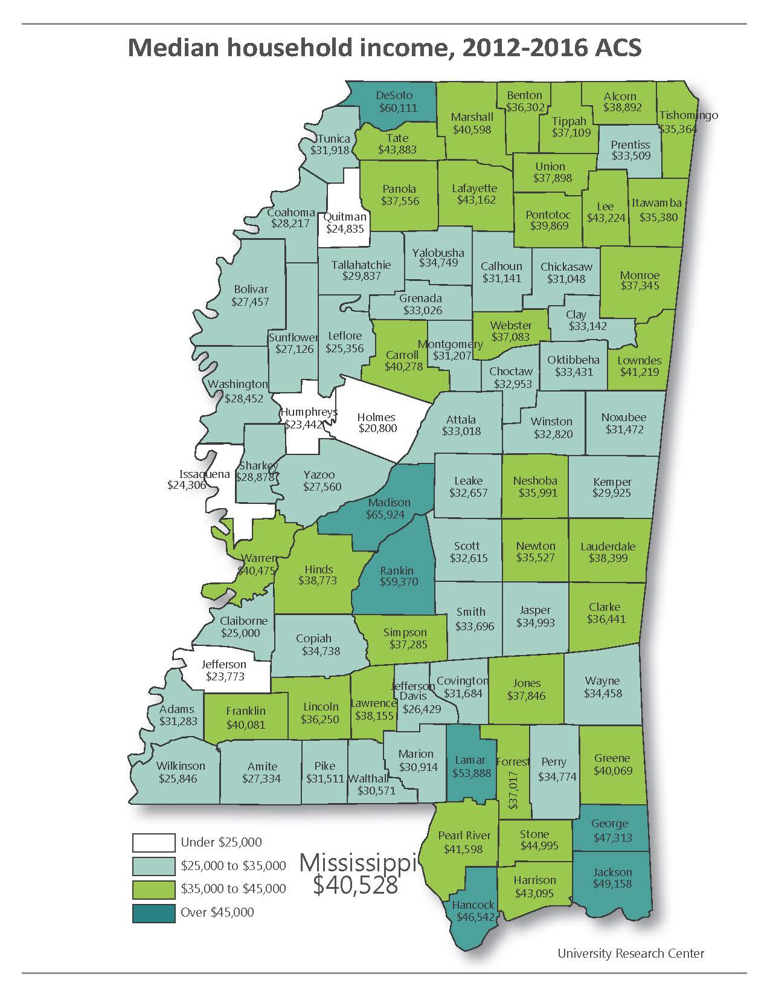
Transfer payments continue to make up a large share of personal income for all South Delta counties. Though no single county in the South Delta area has the highest percentage of transfer payments as a component of personal income in the state, the regional average is 37.7%. This percentage is well over Mississippi’s percentage of 26.7. Transfer payments are government payments to individuals that are not paid in return for goods and services to the government. Examples include social security, unemployment compensation and welfare payments.
In 2010 36.9% of South Delta’s citizens were living below the poverty level. In 2016 that percentage had decreased slightly to 36.1%. Although slightly improved, the percentage of persons living below the poverty is still over twice the national percentage. The segment of the population with the highest percentage below the poverty level is family households with a female head of household.

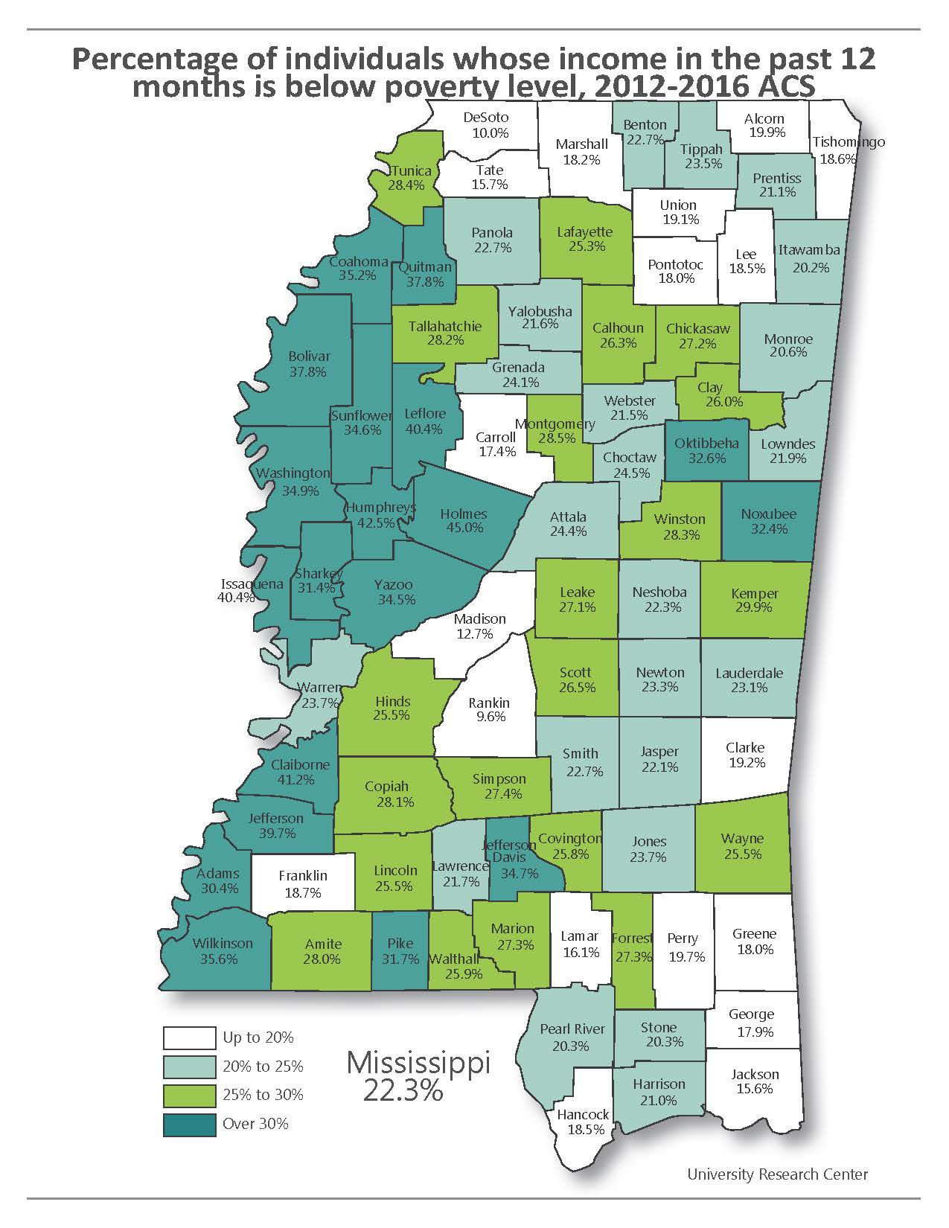

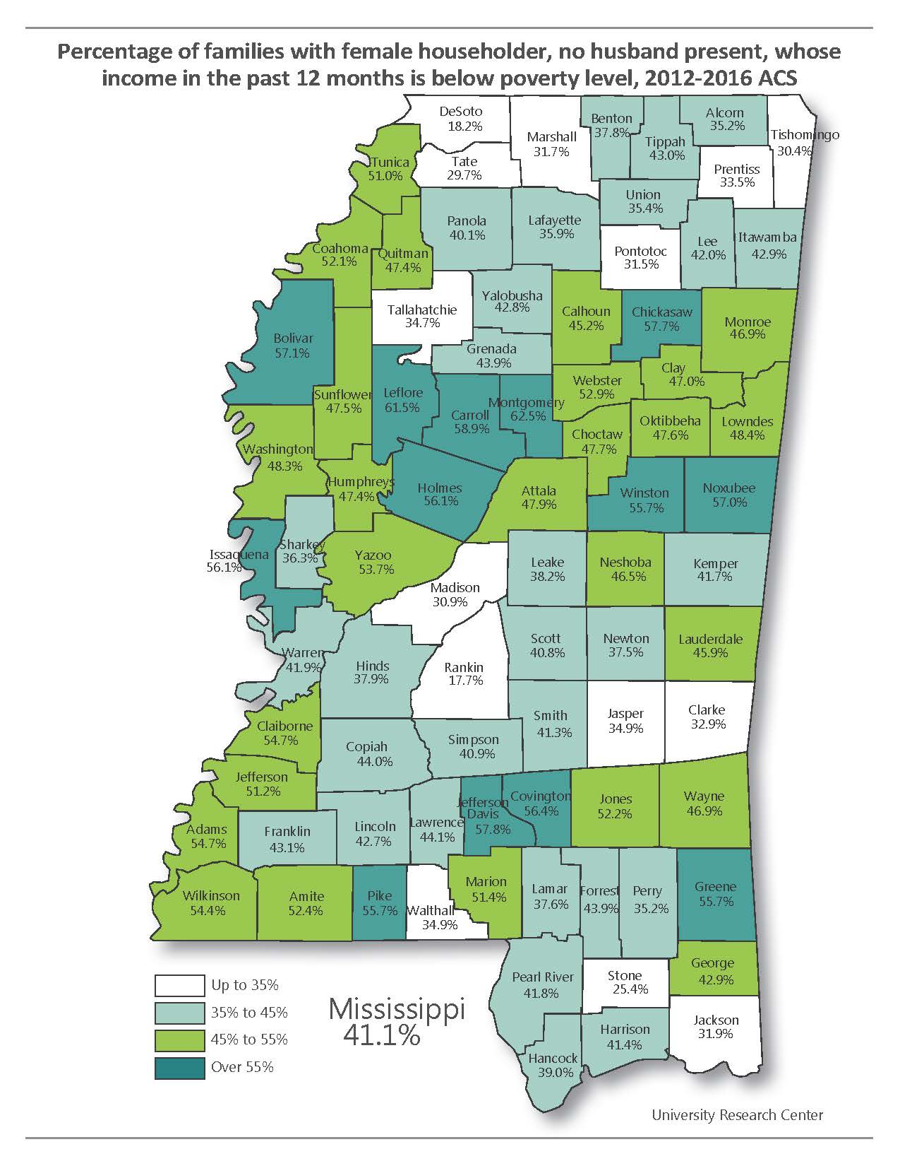

The educational attainment level within the District is improving; however, it is still lower than that of the State and the Nation. In 2016 74.4% of the District’s total population above 25 years of age completed high school or above, compared to 83% for the State and 87% for the Nation. Education levels in the District have improved considerably since 2000, from a 50.7% high school completion percentage to 74.4%. These improvements are encouraging, but there is still much to be done in order for the South Delta region to compete in the State, the Nation, and the World.
Strategic Finding: With regard to income and education, these two factors must be one of the major focal points for improvement of the region. All other man-based factors are dependent on these things for improvement. The improvement of workforce training is helping to make the region more competitive in attracting skilled employment opportunities; however, as long as the level of educational attainment among the working age population is so much lower than the State and the Nation, significant economic development and high paying job opportunities will continue to pass the region by.
Employment and Labor Force

The District’s labor force steadily declined from 66,811 in 1960 to 57,565 in 1970, rebounded in 1980 to 60,865 continued upward in 1990 to 64,030 and has fallen drastically to 55,624 in 2010 and even farther in 2017. The 2017 District labor force was 42,720 of which 39,548 were employed. The June 2018 District labor force, according to the Mississippi Department of Employment Security, was 43,000 of which 39,460 were employed. Although, the District unemployment rate is trending downward, it is doing so much more slowly than the state and nation. The June, 2018, unemployment rate for the South Delta area was 8.2% and for July, 2017 it was also 8.2%. These two numbers don’t give the impression that anything is improving; however, looking at the 5-year trends for each of the counties in the District as well as the state and nation proves that things are taking an overall turn for the better throughout region and the nation. Bolivar County’s unemployment rate in 2013 was 12% and in 2017 it was 7.7%. Humphreys County’s unemployment rate in 2013 was 18.2% and in 2017 10.6%. Issaquena County had an unemployment rate of 22.2% in 2013; however, in 2017 the unemployment rate was down to 10.2%. Sunflower County’s unemployment rate for 2013 was 14.7% decreasing to 8.2% in 2017. Washington County had a 2013 unemployment rate of 15.5% and had a rate of 8.2% in 2017. Mississippi’s 2013 unemployment rate was 9.1% and that of the nation was 7.3%. Both the state and the nation have seen major improvement in these numbers with 2017 rates of 5.8% and 4.3% respectively. None of the Distric’s unemployment numbers indicate that the economic turnaround being experienced throughout the rest of the country has fully made it to the Delta but, they do indicate that things are on the way to improving if all factors are addressed.
Assuming a continued average labor force participation rate of 49.95%, or better as opportunities improve and people re-enter the labor market, the region is poised to fulfill the employment needs of the type businesses that have become the focus of ongoing and improved recruiting efforts throughout the Delta.
Strategic Finding: It is apparent, from the information provided, that the unemployment rate in the South Delta region is still well above that of the State and the Nation; however, the situation appears to be improving as more partnerships are formed, more collaborative efforts are launched and innovative thinking is utilized. Bringing new job opportunities to the area is very important. However, retaining the jobs currently in the area is also of the utmost importance. It is imperative that the counties of this region and SDPDD work together to provide existing businesses the opportunities for expansion and prosperity.

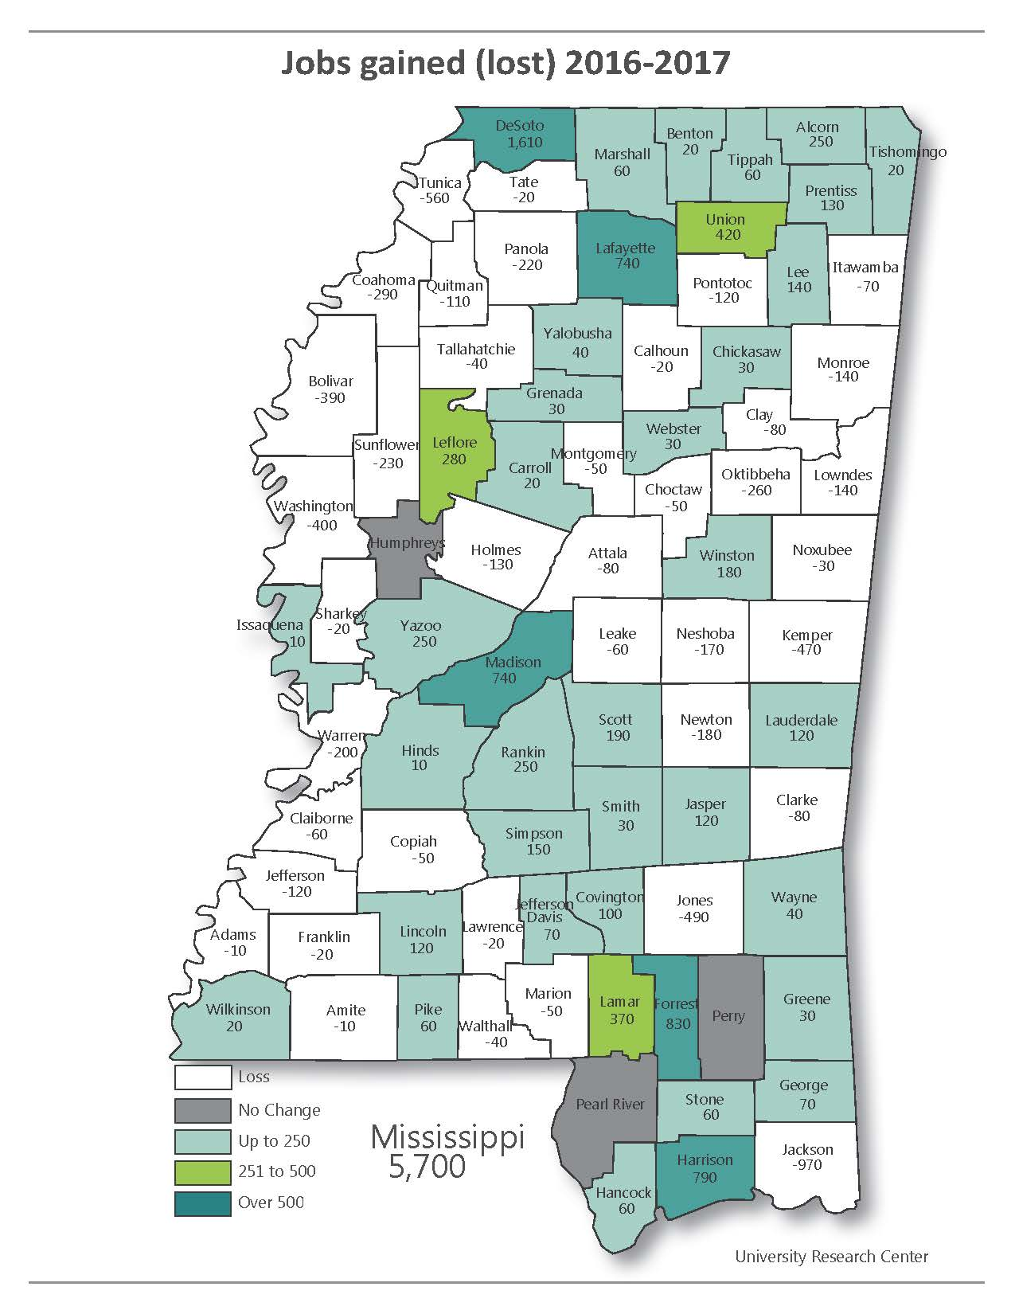
One component of this is a workforce that improves and advances with time and technology. To this end the District is the fiscal agent for the Delta Workforce Investment Area (DWIA). It provides the administrative functions associated with the Workforce Investment Act. Six South Delta staff members currently provide support to the Board and coordinate WIA programs and activities in the 14-county workforce area.
In accordance with the Workforce Investment Act of 1998, it is the purpose of the Delta Area Workforce Investment Area Board to provide workforce activities in the local area that will increase the employment, retention and earnings of participants and increase occupational skills attainment by participants, and, as a result, improve the quality of the workforce, reduce welfare dependency and enhance the productivity and competitiveness of the fourteen counties which constitute the Delta Workforce Area.
In FY’07, the DWIA was awarded $10 million to serve WIA eligible adults, dislocated workers and youth, since then the awards have steadily decreased, as is the case with all Federal and State funding, yet the need continues to increase as the Region, State and Nation fall farther behind the rest of the world in the ultra-competitive global market. Seven WIN Job Centers (one-stop operators) in the 14 counties provide adult and dislocated worker services. The DWIA focuses a lot of activity on economic development to recruit new businesses and retain existing businesses through On the Job Training and Customized Training. WIA eligible participants are provided services through Individual Training Accounts to help them get a first job or a better job.
New efforts are underway in the DWIA to focus on sector training initiatives to address local needs. The DWIA will be exploring specific job sectors and will allocate a certain amount of funds to that specific sector. Some areas to be considered include health care, hospitality and advanced manufacturing.
These sector initiatives will focus on key industries, promote education and training, provide opportunities for career advancement and create new jobs while building the area’s skilled workforce. These efforts will also help create shared objectives and priorities between public and private partners to leverage new and existing resources.

Housing

Housing characteristics in the South Delta region are directly related to the environment of the population. One of the negative housing characteristics in the area, as well as in the State, is the age of housing. Of the 52,086 housing units in the six-county area 12.67% were constructed prior to 1949. This percentage, though not large, does indicate some definite deteriorating factors among the housing stock in the area. This figure is not quite double the percentage for the entire state. Conversely, the percentage of housing units in the region lacking complete plumbing and/or kitchen facilities is half that of the state. This is an indicator that some efforts are being made to improve the existing housing stock. The fact remains that with these older units it is difficult to maintain and make repairs especially when the population is aging and a primary source of income in the area is transfer payments. It is also an unfortunate by-product of population loss, as well as, the regional and national economy that there is very little housing construction taking place in the region. not much of a new housing stock to replace these older homes. Only 4% of the area’s housing stock has been constructed since 2010.
According to the 2012 – 2016 American Community Survey conducted by the U. S. Census Bureau there are 19,929 renters in the South Delta area. This reflects a slight increase in renters from the 2010 Census. Some studies have shown a need and desire among renters to become homeowners; however, financing for low- and moderate-income families is often difficult or even impossible to obtain. Experience has shown that not everyone with a desire to own a home is capable of doing so. South Delta has, when programs are available, attempted to address this need through some innovative financing and down payment assistance. These programs, available to specific units of government, have virtually disappeared. The programs that are now available are on an individual basis and no longer involve local governmental units.
A number of the 24,664 owner-occupied units in the District area need minor to major repairs. The District from 2005 to 2015 assisted local units of government with reconstruction/rehabilitation projects that addressed 137 sub-standard, dilapidated housing units. This program was extremely helpful to many low and very low-income homeowners. (See the following table.) Unfortunately, since 2015 the program has changed administrative agencies and shifted priorities. These factors along with very limited funding for HOME (Home Investment Partnership Program) have made it nearly impossible to help those homeowners that are truly in need.
HOMEOWNER REHABILITATION/RECONSTRUCTION PROJECTS 2005 - 2015
 |  | Units |  |  |  | Units
Project | Year | Built |  | Project | Year | Built
Silver City | 2005 | 4 |  | Rosedale | 2012 | 3
Silver City | 2007 | 2 |  | Inverness | 2009 | 4
Benoit | 2005 | 4 |  | Inverness | 2012 | 2
Benoit | 2007 | 4 |  | Shaw | 2008 | 5
Drew | 2005 | 4 |  | Hollandale | 2008 | 5
Drew | 2007 | 4 |  | Hollandale | 2011 | 3
Drew | 2012 | 4 |  | Anguilla | 2009 | 5
Mayersville | 2006 | 3 |  | Moorhead | 2009 | 2
Mayersville | 2008 | 1 |  | Washington County | 2009 | 4
Mayersville | 2011 | 2 |  | Louise | 2009 | 3
Sunflower | 2006 | 4 |  | Bolivar County | 2009 | 3
Sunflower County | 2006 | 5 |  | Rolling Fork | 2010 | 2
Sunflower County | 2011 | 5 |  | Leland | 2010 | 3
Sunflower County | 2015 | 5 |  | Leland | 2015 | 2
Isola | 2009 | 2 |  | Issaquena County | 2011 | 2
Isola | 2012 | 2 |  | Ruleville | 2011 | 3
Arcola | 2007 | 3 |  | Greenville | 2012 | 4
Arcola | 2010 | 5 |  | Shelby | 2013 | 4
Humphreys County | 2007 | 4 |  | Sharkey County | 2013 | 5
Belzoni | 2007 | 2
Rosedale | 2007 | 4 |  | TOTAL |  | 137

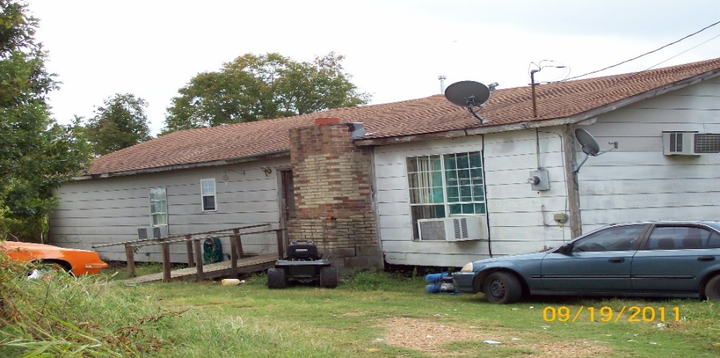 BEFORE
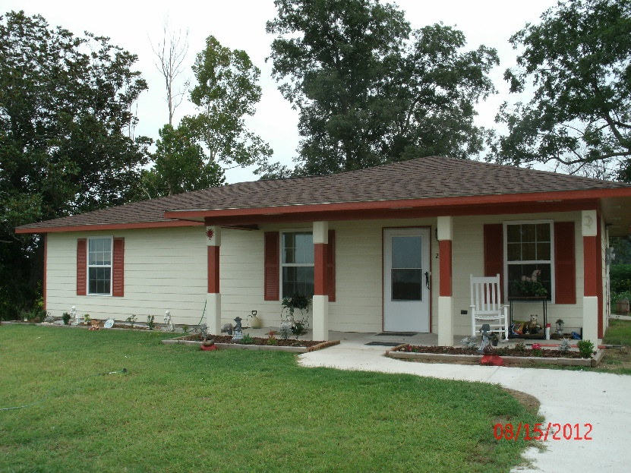
AFTER

Strategic Finding: With the realization that it is very much a component of economic development, housing has become an issue in the area. Housing stock deficiencies, especially houses affordable to middle income families are a serious deterrent to industries that may desire to locate here. Houses are not being built in the District. According to some urban and regional planners, “if you aren’t building, you are dying”.

Clusters/Sectors

According to the Sector Strategy Plan developed by the Delta Workforce Development Area, the South Delta region has three significant clusters/sectors, manufacturing, health care, and agribusiness. Along with these significant clusters/sectors there are a few other industry categories that, although not included in the Sector Strategy, are currently relevant enough to remain a focus of industry/job recruitment efforts. (aerospace, metalworking, automotive, distribution, and plastics) Based on information obtained from the Mississippi Department of Employment Security, retail/wholesale has the highest number of employed persons in the 14-county Delta Workforce Area. Away from the more urban settings of the far north delta, retail is not necessarily sustainable as a growing sector for employment. The three significant sectors were established based on job growth projections, sustainability and Delta Strong. Agriculture, although no longer the basis for all of the economy of the region, is still a major component. In 2006 the largest cluster in the area appeared to be Agribusiness, Food Products and Services. Since then agribusiness has slipped behind health care and social assistance. Processed food production is still a part of the manufacturing-based sector; therefore, it brings together the sectors of manufacturing and agribusiness.
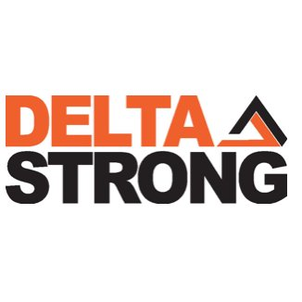
The District has the largest medical facility within a 120-mile radius. Four of the six counties in the region have hospitals located within their boundaries. Delta Regional Medical Center, located in the City of Greenville, is the largest medical facility in the area. Issaquena County and Humphreys County do not have medical facilities of their own; however, Humphreys County has recently participated in a pilot project with the University of Mississippi Medical Center to establish a critical care clinic. The health care and social assistance sector has begun to outpace agribusiness as a source of employment in the region. The manufacturing sector, in the current climate, is where the majority of job creation/improvement strides can be made. The Delta Strong initiative started to bring about improvement and growth in the manufacturing sector/cluster. Delta Strong is a new regional branding, marketing, and business attraction program aimed exclusively toward attracting new manufacturing opportunities to the Mississippi Delta. The initiative is supported by private sector financial institutions, our planning and development districts, port terminals on the Mississippi River, local economic development foundations, and our utility and infrastructure partners. This strategy, led by the Delta Council Development Department, is a four-year plan which includes outcome measurements and transparency that positions the Mississippi Delta region as a major player in the attraction of manufacturing, distribution, and warehousing operations.
Although tourism is not considered a significant sector/cluster it is an up and coming component of the local economy and employment. The region is steadily taking hold of the tourism opportunities that are related to the region. Music and museums based on music and musicians are now a force in the local economy and driving hospitality industry entrepreneurship. The construction of the B. B. King Museum, the Grammy Museum Mississippi and the Delta Music Institute has been the catalyst for new restaurants, hotels and shops that are springing up in the area. In addition to music, outdoor sporting activities such as hunting and fishing are helping to bring about outfitter and guide businesses as well as sporting goods retailers.
Strategic Finding: The information garnered from the sector/cluster analysis is an indicator of “the way things have been” in the South Delta area but, it is also an indicator of the opportunities that can be taken advantage of moving forward. The low levels of training and educational attainment have left the majority of the labor force qualified for and working at the lowest paying jobs. This is where the Workforce Development Area comes and provides the training necessary for these workers to fill the gap of the middle-skill worker shortage. These sectors/clusters must be nurtured in order to provide more opportunities for employment and economic growth.

INFRASTRUCTURE

Water

The principal difference between the infrastructure of urban and rural areas is in the capacity of the water and sewer systems. Urban networks generally have a superior capacity per person in both quantitative and qualitative evaluations. Water supplies in the urban area are more reliable and have better treatment facilities. A greater amount is available on a per capita basis for domestic purposes and also for fire flows in emergency situations. In addition to municipal water and sewer systems, there are water associations operating within the District to provide domestic water supplies to rural areas. Most of these were organized through the United States Department of Agriculture – Rural Development and were designed to furnish domestic needs only. In most instances, industrial uses of fire flow demands would be beyond the design capacity of such systems.
In accordance with the Federal Safe Drinking Water Act of 1996, the State of Mississippi has implemented a Capacity Development Program to improve the technical, managerial, and financial capacity of the state’s public water systems and to prevent the creation of new systems that do not have the technical, managerial, and financial capacity to comply with current and future provisions of the Act. Included in the requirements of the Act is the development of an annual report on all of the public water systems in the State of Mississippi. This report provides much needed information in the development of projects throughout the District. It not only indicates water production capacity but provides ratings to discern the capability of the system on the issues of technology, management and finances. These factors must be considered for projects to improve these water systems as well as for projects that rely on access to water.
Strategic Finding: It appears that the populated areas of the region are generally served by public water systems. There may be some pockets of population that are too remote to be included in an organized water system and must rely on private wells for access to water. Many of the unserved areas surrounding municipalities or organized communities have been recently connected to existing systems. Those remaining will be connected as funding becomes available. One of the major concerns of the area is not access to water but, access to water systems that are technologically sound, well managed and financially capable of remaining viable. The second, equally major concern is the aging components of the municipal water systems in the region. Many of these systems are beginning to experience catastrophic failures. These issues will have to be at the forefront of infrastructure improvement planning for many years to come.

Sewer

Urban sanitary wastewater facilities are characterized by more sophisticated treatment methods and consequently higher quality treated effluent. Most of the small towns in the district utilize lagoon treatment while the largest city uses a mechanical treatment plant. Several of the communities that were utilizing mechanical plants then changed to lagoon type treatment for cost savings are being forced to make plans to return to the mechanical systems. This issue has just recently arisen with the changes in the permitted limits for discharge. Most of the small communities in the region cannot meet the new limits because of location and environment. These communities had discovered that the operation and management costs related to mechanical treatment was too high for their financial capacity. Unfortunately, the choices for their wastewater treatment may become very limited.
A number of the unincorporated communities in the District have formed utility districts, which allowed them to provide sewer service to area residents. These systems may face the same uncertain future as the municipal systems and may have to return to a form of septic system for their wastewater service needs.
Strategic Finding: More and more information on the health hazards of poor wastewater handling is being disseminated to the public. As this happens more communities are seeking ways to improve their quality of place and the human condition of their area. Additionally, the changes to discharge requirements implemented by the Environmental Protection Agency will bring about the need to revisit wastewater systems that have recently been addressed. Efforts to assist both units of local government and unincorporated communities in identifying funding for addressing these issues must continue. These efforts are not only vital to maintaining a healthy populace but also in attracting people and business opportunities to the region.

Transportation

The South Delta area has a multi-modal transportation network capable of handling almost any type of cargo. Proximity to the Mississippi River makes water transportation of bulk materials possible. The public ports at Greenville and Rosedale offer shippers the opportunity to import or export large volumes of goods to regional, national or international markets. Numerous industrial port facilities also line the harbor front. Unfortunately, both of these port facilities are full and no longer have useable land available to offer industries wishing to locate at the ports.
The remainder of the transportation system in the District is characteristic of the State as a whole. The principal north-south and east-west thoroughfares are U. S. Highways 61 and 82. Greenville, the largest city in the District, is the site of the relatively new Highway 82 Bridge. Greenville has one of the four bridges in the state that crosses the Mississippi River. The crossing currently gives Greenville a locational advantage because of its exposure to larger volumes of traffic and its access to a greater regional trade area. Highway 61 passes through Leland, which is eight miles to the east of Greenville. A secondary roadway network that serves even the smaller communities with paved access roads complements the primary thoroughfares. The counties build and maintain a network of farm-to-market roads that are either paved or gravel surfaced. This operation is assisted by both State and Federal funds, but the county provides the manpower and management.
The South Delta Region, just like the remainder of the state, is experiencing a critical situation on the farm-to-market roads serving the area. Based on the current criteria and inspections conducted by the Federal Highway Administration, there is a need to rehabilitate or reconstruct 84 currently closed timber bridges located within the six-county south delta footprint as possible. The number of bridges to be addressed will rise as the next round of inspections is conducted. The long-range plan is to rehabilitate or reconstruct these timber bridges with concrete pilings or concrete box culverts as each bridge situation dictates. The current timber bridges, although some are 60 or 70 years old, outlived their design life at around 30 or 40 years. Concrete components, with care and maintenance, could possibly double the design life of these bridges.
A proposal for another bridge over the Mississippi River has been approved as part of the construction of Interstate 69 (I-69) an intercontinental highway linking Canada, the United States and Mexico. It appears that the most likely route for I-69 will be through southern Bolivar County and to the north of the City of Greenville. Greenville has been identified as a location requiring further study for access and connectivity. The location of I-69 and any connector routes through the South Delta Planning and Development District would have a major economic impact on the region.
The only commercial airport in the District is located in Greenville, which is within 75 miles of any point in the District. The regularly scheduled commercial flights are regionally oriented, providing a commuter style connection to the larger air facility in the City of Nashville, TN. Chartered flights and air freight services are also available.
The Genesee and Wyoming Railway, formerly known as the Columbus and Greenville, provides the South Delta District with rail-freight service. The Genesee and Wyoming is an east-west railway that once crossed the entire state. Now the railway only provides service from Greenville to Greenwood. This service is marginal at best considering the current track conditions. The Great River Railroad, although still in existence, is no longer in operation. Rail access to industrial sites is currently very limited. The Great River Railroad has been the focus of an effort to find funding for revitalization of the north south connector that would serve the growing Port of Rosedale and provide east west rail access at Greenville.
Strategic Finding: Transportation facilities in the South Delta region must be improved in order for the area to be competitive with the state, the nation and the world. Every component of the transportation system within the District needs improvement. Some, like the Port of Greenville and the Rosedale-Bolivar County Port, have taken steps to improve their facilities and the services offered. However, both of these port facilities have many more improvements that could be made, not the least of which is taking the steps necessary to open more land for development.
Air transportation, although not terrible considering the population of the area, should continue to be at the forefront of improvement considerations. An area that does not have access to a functioning commercial airport will not be considered for business location over an area that does. Therefore, it is imperative that the Mid-Delta Regional Airport be maintained at its current level of service and improved with every opportunity.
Rail service in the District is not even remotely close to the level necessary to make this area a viable option for business location or in support of business that has located elsewhere in the state. The Great River Railroad, that provided service from the Port of Rosedale to a junction with the Genesee and Wyoming in Leland, is currently not in operation due to age and deterioration of the equipment and rails. The Great River Railroad is actively seeking opportunities to rehabilitate the line. The Genesee and Wyoming has shut down service beyond Greenwood. With the location of the Toyota plant at Tupelo and the steel mill in Columbus, it is critical that the South Delta region have rail access to the eastern side of the state. Plans must be made for the future to keep access to rail service in South Delta area. Even though rail traffic has been very light in recent years, the total loss of rail service would be highly detrimental to economic development in the area.

Industrial Parks and Sites

Nine local governments in the District – Greenville, Cleveland, Indianola, Shelby, Rosedale, Belzoni/Humphreys County, Rolling Fork, Issaquena County and Hollandale – have organized industrial parks. Several smaller communities have industrial sites reserved and serve those sites with utilities, but they are not of a scale that would classify them as industrial parks.
Light and heavy industries are located throughout the District and their contribution to the economic growth of the District has been considerable. The total land area presently occupied by industrial users is very small with the greatest concentration being in Greenville, Cleveland and Indianola. The larger communities are better able to support the needs of most manufacturers. Consequently, it can be anticipated that their dominance of attracting new industries in the District will continue.
Strategic Finding: Currently the only shortage of industrial development space within the District is at the Port of Greenville and the Rosedale-Bolivar County Port. All other industrial parks and sites have land available for development. Most of these sites are served with the necessary infrastructure. However, some of the infrastructure serving these industrial parks is beginning to age considerably and some has been surpassed by the needs of industries currently being served. Future efforts must include upgrading and maintaining existing industrial parks and sites. This is especially true in light of the current Delta Strong efforts to focus on smaller manufacturing recruitment. Beyond this, efforts must focus on the development of larger regional industrial development areas designed for the larger type of industry such as an automotive manufacturing facility. This need not be the first item of business but as I-69 continues toward completion it should be addressed.

Water Resources

One of the primary natural resources of the District is the abundant water supply. In addition to the Mississippi River, which forms the western border of the District, underground aquifers have provided domestic water supplies of very good quality. Lakes and ponds provide numerous opportunities for water-oriented recreation as well as aesthetic enhancement of building sites.
The Yazoo River is navigable in the eastern portion of the District, and a port has been proposed for Belzoni. The ports of Greenville and Rosedale, along with a future port at Belzoni, will provide reasonable access to water transportation. Then all areas of the South Delta region will be within 50 miles of a river port.
Strategic Finding: In recent years it has been reported that groundwater supplies are dropping and measures should be undertaken to conserve the State’s water resources. The dwindling water supplies in the Delta are due primarily to heavy agricultural uses such as crop irrigation. The groundwater is not being replaced fast enough to offset the consumption. Local farming operations are beginning to embrace water reclamation activities for the conservation of this valuable resource.
Port expansion projects, as with all new major construction projects in the South Delta area, will have careful environmental evaluations in order to assess the impact of the projects on their surroundings. Various sections of the Environmental Policy Act of 1969 have set forth methods of improving the quality of previously damaged areas, such as streams polluted by domestic waste. In order to assure the continued potential of the District’s natural resources for future generations, it is imperative that our present action be consistent with conservation goals for the future.

EXTERNAL FORCES

Natural

The State of Mississippi, like any other state, is susceptible to a number of natural and man-made hazards. The South Delta region faces the same hazards as the rest of the state and some not associated with the entire state. The region, just like the rest of Mississippi, is threatened annually by devastating tornadoes, drought and severe thunderstorms. Not as frequent, but just as devastating, is the threat of winter storms and hurricanes that approach the state from an angle leaving the region vulnerable to spin off tornadoes and flooding. The South Delta region, by its very nature, is extremely vulnerable to flooding resulting from storms and prolonged periods of rain. Additionally, the threat always exists for a break in the levee that retains the Mississippi River.
In addition to threats already mentioned, is the region’s location along the New Madrid fault. This location expands the list of natural threats to include earthquakes. Though the threat of an earthquake may seem very small it is a very real possibility and like the others must be included in emergency planning efforts.

Political

There are several politically based external forces that are at work in the South Delta Planning and Development District. These political forces include Federal and State programs as well as the current pro-business administration.
Portions of the District were included in the Mid Delta Empowerment Zone Alliance. This Empowerment Zone designation, a joint program through the U. S. Department of Housing and Urban Development for urban zones and the U. S. Department of Agriculture for rural zones, had a ten-year time frame. Even though the time frame for the Empowerment Zone has expired, the benefits of this designation are still in evidence. The broad and flexible usage of the funds associated with the designation provided an additional resource for financing projects of all types. These projects have included water system improvements, sewer system improvements, port facility additions and drainage improvements just to name a few. All of these projects continue to provide benefit to the citizens of the region long after the expiration of the Empowerment Zone designation.
Now, there are 7 census tracts within the District that have been designated for the very new Opportunity Zone program. The Tax Cuts and Jobs Act of 2017 established Opportunity Zones as a new community development program aimed to encourage long term investments in low-income and rural communities.
Private investors can earn tax relief through investments made in qualified Opportunity Funds. In turn, Qualified Opportunity Funds must be invested in designated Opportunity Zones. Low-income communities, defined as census tracts with a poverty rate of 20 percent or greater and/or family income less than 80 percent of the area’s median income, were eligible for consideration as Opportunity Zones. Each state could nominate up to 25 percent of the total number of eligible low-income community census tracts within the state.
The U.S. Department of Treasury approves the nominated census tracts and administers the Opportunity Zone Program. States were required to submit Opportunity Zone applications to the U.S. Department of Treasury no later than March 21, 2018. Mississippi accepted and reviewed applications for tracts to receive consideration. Governor Phil Bryant submitted his nominations to the U.S. Department of Treasury on March 19, 2018.

Economic

The previous cluster analysis leads us to a number of conclusions concerning the impact, of the national economy as a whole and private sector actions, on the economy of the South Delta region. One would assume that two of the higher-ranking clusters, agribusiness and health care and social assistance, would not feel the same impact of the ups and downs of the national economy as other clusters might. Food and health care are items of necessity and as such would not seem to be as easily impacted by swings in the economy. However, as everything, including the identified clusters/sectors, becomes part of the global economy they become subject to the ups and downs. Advances in technology are impacting all three of these sectors/clusters on an almost daily basis. It is imperative that the South Delta region adapts to the changing economic, industrial and service climate. Taking advantage of the changes can improve the region’s business attractiveness.
Multi-million-dollar private sector investment in the State of Mississippi should be a boon to all areas of the State, not just the location of the investment. These benefits may be somewhat indirect but, benefits nonetheless. The location of the Nissan, Toyota, and Continental plants in the state can improve the economy of the South Delta region through investment and job creation by focusing on bringing ancillary businesses to the region. Additionally, these major investments improve the overall financial status of the State thereby allowing the Legislature the opportunity to increase the funding for programs that help all areas of the State. These programs include the Small Municipalities and Limited Population County Grant Program, the Mississippi Works Program and the Development Infrastructure Program.

Social

Although the overall population of the District has continued to decrease, the Hispanic population has been on a very slow but steady rise. Based on statistics and regional trend observations this increase is likely to continue. As the overall population declines through out- migration and the participating workforce declines through out-migration and aging another segment of the population will step in to fill the void.
Strategic Finding: It is crucial for the future economic health of the South Delta region that the external factors be considered for future project development and implementation. Capitalizing on the changing agribusiness sector, fostering the health care and social assistance sector, focusing on recruiting the 50 – 200 employee manufacturers and always supporting the arts, entertainment, and tourism sector is imperative for the future growth and stability of the region.

Resiliency

The Economic Development Administration considers resilience in three ways: a region’s ability to recover from a disaster; a region’s ability to withstand a disaster, and; a region’s ability to avoid/prevent a disaster. Because of the potential for natural, economic, and political disasters it is essential for development to be as disaster resistant as possible. It is also critical to understand that disasters do happen. In the case of a disruption to “normal” it will be necessary for South Delta to act as the central point of contact for coordination, Information dissemination, and grant administration. It is imperative in these situations to have prior knowledge of the assistance available from agencies such as the Economic Development Administration, the Federal Emergency Management Agency and the U. S. Department of Housing and Urban Development is imperative. Experience with these agencies makes the District the logical focal point for post-disaster recovery.
It is also important to not lose site of the fact that the district can and should be the leader in pre-disaster planning and development guidance. When one thinks of a disaster, it is generally with the idea that it is very sudden. That can certainly be the case. Economic and natural disasters that have occurred in the region, however, to this point have been rather slow moving. A disaster is never a particularly good thing; however, at the pace of the events that have occurred in this area, such as the 2011 flood, have provided opportunities to study and learn. The District in its collaborative effort with Delta Strong is focusing industry placement away from flood prone areas and recruitment of industries that are smaller and more numerous. The “don’t put all of your eggs in one basket” style of development. If all of your area employment relies on one industry that falls to some type of disruption, recovery will be much more difficult. In addition to this more proactive approach to development of new business and industry, South Delta is also actively trying to assist existing industry to become more resistant to issues that may arise.

SWOT Analysis
Strengths/Weaknesses/Opportunities/Threats

Strengths

- Location – Mississippi River Ports, highways, short-line rail, and airports.
- Delta Strong
- Workforce Training – Delta Workforce Investment Area
- Newly Formed Regional Collaborations
- Post-Secondary Educational Opportunities
- Agricultural Opportunities
- Abundant Natural Resources
- Available Industrial Sites
- ACT Work Ready Communities
- Tourism – Points of Interest

Weaknesses

- Millennial “Brain Drain”
- Aging/Deteriorating Infrastructure
- Diminishing Availability of Skilled Labor
- Education System K – 12
- Inadequate Worker Soft Skills
- Lack of Living Wage Jobs
- Drug Use Among Working Age Population
- Public Attitude
- Over-Dependence on Governmental Assistance
- Lack of Middle-Skill Workers
- Lack of High-Skill Job Opportunities

Opportunities

- Delta Strong – Regional Collaboration of Public and Private Entities
- Workforce Training Availability
- Promotion of Vocational/Technical Job Opportunities/Skills Training
- Delta Strong – Rebranding the Region for Industry Recruitment Purposes
- Workforce Training – Soft Skills Emphasis
- Capitalize on Tourism Opportunities
- Creative Placemaking/Maker’s Space Opportunities
- ACT Work Ready Certifications

Threats

- Catastrophic Failure of Aging Infrastructure
- Migration Patterns
- Lack of Funding for Infrastructure
- Lack of Living Wage Jobs
- Drug Use
- Lack of Industrial Diversity

Goals and Objectives
In the original study of The Mississippi Delta that formed the basis for the Delta Regional Commission, it was surmised, “A Delta without change is a symbol without meaning”. In order to progress during the 21st Century, a change of direction is required. This change in direction will be guided by the findings generated in the analysis section of this plan as well as by the input received through a survey of leaders throughout the District. The Regional Analysis, the survey and previous CEDS have established some very broad goals for the District. These goals have then been looked at in terms of objectives that when achieved will help in attaining the goals.
These goals, resulting from establishment of needs, pertain to a wide variety of issues in the region. The issues range from the very broad, economic improvement, to the very specific, construction of I-69 and connectors. The broad goals and objectives, while they may not specifically state a strategic finding, are designed to address these findings. All of these goals and objectives should work hand in hand to improve the region. The items addressed in this section of the document should be considered the “road map” for South Delta Planning and Development District for the next five years.
Goal: Attract new private sector investment to the region while retaining and expanding existing business.
- Focus on and encourage downtown development
- Encourage the development of tourism-based business, capitalizing on the cultural history of the area as well as the outdoor recreational opportunities
- Focus on recruitment of smaller 50 – 200 employee industries
- Continue efforts to expand and improve ports along the Mississippi River
- Continue collaboration and support of Delta Strong
- Assist local developers, through Delta Strong, in marketing of industrial parks and sites
- Coordinate financial resources for economic development projects
- Pursue funding for economic development projects
- Continue to develop existing clusters
- Focus efforts on assisting business development related to agribusiness, health care and manufacturing

Goal: Develop an ethically sound, well-trained and educated workforce
- Encourage and assist in the development of employment opportunities in the private sector
- Coordinate activities and training needs with the Delta Workforce Investment Area
- Encourage the use of “One Stop” (WIN Job Centers)
- Encourage the development of partnerships between local schools and business leaders to emphasize the importance of education and training
- Continue to provide high quality training through the use of appropriate providers
Goal: In order to enhance competitiveness in the realm of economic development, upgrade and maintain basic infrastructure
- Continue efforts to assist in the location of I-69 within the District
- Seek funding for planning requirements and implementation of I-69 connector routes
- Continue to seek funds for the implementation of water, sewer, storm drainage and street improvement projects
- Assist communities in updating needs assessments
- Establish a geographic information system to maintain infrastructure records for member governments
- Encourage establishment of telecommunications infrastructure

Goal: Improve the “quality of place” within the region to enhance competitiveness
- Continue implementation of housing programs designed to improve quality of the housing stock
- Continue implementation of home buyer activities thus establishing pride of ownership as well as increasing tax base
- Seek funds for implementation of recreation projects
- Focus on downtown transportation enhancement programs
- Seek funds for construction of community centers and multi-purpose facilities
- Encourage the implementation of zoning ordinances
- Encourage the development of localized comprehensive plans
- Main Street Program participation should be encouraged
- Focus on maintaining and expanding health care facilities

STRATEGIC PROJECTS, PROGRAMS AND ACTIVITIES

The following pages of this document provide a list of potential projects. These projects are based on the overall goals and objectives set forth on previous pages. The list includes very specific projects of a regional nature as well as rather broad projects based on the desires of individual communities. Some of the activities listed are in the beginning stages of implementation while others are still in the very early planning and development stage. Regardless of their status or range of benefit, all of these projects are important in one way or another to the South Delta Planning and Development District and its citizens.
Funding for these projects could come from a number of sources. Federal, state and local funds could be used for the implementation of these projects. Private sector funding may also be necessary for the larger projects. Federal sources could include but, are not limited to, Delta Regional Authority, Economic Development Administration, USDA Rural Development, HUD, Federal Highway Administration and the Environmental Protection Agency. State funds may come from the Mississippi Development Authority, Mississippi Emergency Management Agency, MS Department of Health, MS Department of Environmental Quality and the MS Department of Transportation.

 |  | Strategic Project, Program or Activity |  | Responsible  Partners |  | Potential  Funding |  | Job Creation Estimate
Regional
Vital |  | Design of I-69 Connectors |  | Bolivar County  Washington Co. |  | Federal  State  Local |  | 100+
Vital |  | Rebuild Railroad connecting Bolivar Co. to Washington Co. |  | Bolivar County  Washington Co. |  | Federal  State |  | 50+
Vital |  | Reopen rail service to the east side of the State |  |  |  | Federal  State  Private
Complete |  | Construct Grammy Museum Mississippi |  | Cleveland  Bolivar Co. |  | Federal  State  Local  Private |  | 10 Direct  144+  Indirect
 |  | Establishment of Revolving Loan Fund for Historic and/or Brownfield Properties |  | SDPDD Area |  | Federal  State  Local
 |  | Construction of I-69 Corridor |  | Federal Highway |  | Federal |  | 100-500
 |  | Completion of Mississippi Blues Trail |  | MS Blues Commission |  | State
 |  | Open development ready land at the Port of Greenville |  | Greenville  Washington Co.  Port Commission |  | State  Federal |  | 25-100
 |  | Strategic Project, Program or Activity |  | Responsible  Partners |  | Potential  Funding |  | Job Creation Estimate
 |  | Open development ready land at the Port of Rosedale |  | Bolivar County  Port Commission |  | State  Federal
Bolivar County
 |  | Recreational Improvements All County Parks |  | Bolivar County |  | State
 |  | Owner Occupied Housing Rehabilitation |  | Bolivar County |  | State
Benoit |  | Sanitary Sewer System Improvements |  | Benoit |  | State  Local
 |  | Construction of Town Maintenance Facility |  | Benoit |  | Local
Beulah |  | Construction of new Town Hall/Fire Station |  | Beulah |  | Local  State
Merigold |  | Owner Occupied Housing Rehabilitation |  | Merigold |  | State
 |  | Downtown Development |  | Merigold |  | Local  State
Mound Bayou |  | ADA upgrades and repairs to City Hall |  | Mound Bayou |  | Local  State
Mound Bayou | Owner Occupied Housing Rehabilitation |  |  |  | Mound Bayou | State
 | Downtown Development |  |  |  | Mound Bayou | State  Local
 | Water System Improvements |  |  |  | Mound Bayou | State  Local
Boyle | Owner Occupied Housing Rehabilitation |  |  |  | Boyle | State
Pace | Water & Sewer System Improvements |  |  |  | Pace | State
 | Renovate vacant school building for multi-purpose use |  |  |  | Pace  Bolivar County | State  Local
 | Strategic Project, Program or Activity |  |  |  | Responsible  Partners | Potential  Funding |  | Job Creation Estimate
Renova | Construction of Public Park & Playground |  |  |  | Renova | State  Local
Rosedale | Owner Occupied Housing Rehabilitation |  |  |  | Rosedale | State
 | Construction of a Community Facility Building |  |  |  | Rosedale | State  Local
 | Rehabilitation of Public Parks |  |  |  | Rosedale | State  Local
Shaw | Wastewater Treatment Facility Improvements |  |  |  | Shaw | State  Federal
 | African American History Recording |  |  |  | Shaw | Federal
 | Downtown Improvements (Sidewalks and Lighting) |  |  |  | Shaw | State  Local
Shelby | Industrial Facility Renovations |  |  |  | Shelby  Bolivar County | State  Federal
 | Downtown Improvements (Sidewalks and Lighting) |  |  |  | Shelby | State  Local
Winstonville | Sanitary Sewer System Improvements |  |  |  | Winstonville | State  Federal
 | Construction of a Multi-purpose Building |  |  |  | Winstonville | State  Local
Humphreys Co.
Complete | Construction of Health and Human Services Complex |  |  |  | Humphreys County | State  Federal  Local |  | 10-25
 | Basketball Court Construction/Park Renovations |  |  |  | Humphreys  County | State  Local  Federal
Belzoni | Improve Public Tennis Courts |  |  |  | Belzoni | State  Federal  Local
 | Water/Sewer System Improvements |  |  |  | Belzoni | State  Federal
Louise | Downtown Improvements |  |  |  | Louise | State  Federal
 | Renovate Town Hall |  |  |  | Louise | State  Local
 | Owner Occupied Housing Rehabilitation |  |  |  | Louise | State
Issaquena County | ADA Compliance of Courthouse |  |  |  | Issaquena County | State Federal
 | Provide Water To Unserved Areas |  |  |  | Issaquena County | State  Federal
 | Construct Additions to County Courthouse |  |  |  | Issaquena  County | State  Local
 | Construct Multi-Purpose Facility |  |  |  | Issaquena County | State  Local
Mayersville | Owner Occupied Housing Rehabilitation |  |  |  | Mayersville | State
Sharkey County |  | Construct Drainage Improvements |  |  | Sharkey County | State  Local
Anguilla |  | Owner Occupied Housing Rehabilitation |  |  | Anguilla | State
 |  | Construction of a Multi-Purpose Facility |  |  | Anguilla | State  Local
 |  | Renovate Industrial Facility |  |  | Anguilla | State  Federal
Rolling Fork |  | Water System Improvements |  |  | Rolling Fork | State  Federal
 |  | Sanitary Sewer System Improvements |  |  | Rolling Fork | State  Federal
 |  | Renovate Public Swimming Pool |  |  | Rolling Fork | Local  Federal
Sunflower County
 |  | Industrial Building Sale |  |  | Sunflower  County | Local  State
 |  | Street and Drainage Improvements |  |  | Sunflower County | Local  State
 |  | Owner Occupied Housing Rehabilitation |  |  | Sunflower  County | State
Drew |  | Sewer System Improvements |  |  | Drew | State
 |  | Owner Occupied Housing Rehabilitation |  |  | Drew | State
Indianola |  | Owner Occupied Housing Rehabilitation |  |  | Indianola | State
Complete |  | Industrial Park Access Road |  |  | Indianola | State | 15
 |  | Construct Fire Station |  |  | Indianola | State Federal
 |  | Renovation of Neighborhood Parks |  |  | Indianola | Local
Ongoing |  | Sewer System Improvements |  |  | Indianola | State  Local
Inverness |  | Purchase Equipment for Fire Department |  |  | Inverness | State
Ongoing |  | Construct Fire Station |  |  | Inverness | Federal
 |  | Owner Occupied Housing Rehabilitation |  |  | Inverness | State
 |  | Street Improvements |  |  | Inverness | State  Local
Moorhead |  | Purchase Three Police Cars |  |  | Moorhead | Federal
Ongoing |  | Construct Wellness Facility |  |  | Moorhead | State Federal  Local
 |  | Street and Drainage Improvements |  |  | Moorhead | State  Federal
 |  | Sewer System Improvements |  |  | Moorhead | State  Federal
 |  | Construct Multi-Purpose Building |  |  | Moorhead | State  Local
Phase I Complete |  | Construct Walking Track |  |  | Moorhead | State  Federal  Local
Ruleville |  | Street Improvements |  |  | Ruleville | State  Federal
 |  | Owner Occupied Housing Rehabilitation |  |  | Ruleville | State
 |  | Sewer System Improvements |  |  | Ruleville | State  Local
Sunflower |  | Street Improvements |  |  | Sunflower | State  Federal
 |  | Construct Community Facility Building |  |  | Sunflower | State  Federal
 |  | Owner Occupied Housing Rehabilitation |  |  | Sunflower | State
Ongoing |  | Sewer & Water System Improvements |  |  | Sunflower | State  Federal  Local
 |  |  | Downtown Improvements (Sidewalks and Lighting) |  | Sunflower | State  Local
Washington Co.
 |  |  | Renovate Buildings for Economic Development Purposes |  | Washington  County | State  Local  Federal
Complete |  |  | Construct Multi-Family Housing |  | Washington  County | State  Federal
Arcola |  |  | Downtown Improvements (Sidewalks and Lighting) |  | Arcola | State  Local
 |  |  | Construct Indoor Recreation Facility |  | Arcola | State  Local
 |  |  | Renovate Public Bldg. For Community Resource Center |  | Arcola | State  Local
Greenville |  |  | Rehabilitate Historic Area of Downtown |  | Greenville | State  Local  Federal | 25-100
 |  |  | Neighborhood Park Improvements |  | Greenville | State  Local
 |  |  | Reconstruction of Major Traffic Arteries |  | Greenville | State
Hollandale |  |  | Purchase Equipment for Fire Department |  | Hollandale | State  Federal
 |  |  | Street Improvements |  | Hollandale | Federal  State
Leland |  |  | Owner Occupied Housing Rehabilitation |  | Leland | State
 |  |  | Water & Sewer System Improvements |  | Leland | Local  Federal

ACTION PLAN

Design of I-69 Connectors | Construction costs  unknown – location to be established | Strategic Finding- Transportation Improvement for Easier Access | Feasibility Study and Environmental Study Phase
The City of Greenville has commissioned studies for the purpose of reviewing alternate routes to I-69. Upon finalization of route selection, South Delta will assist in obtaining funding for the construction of the connector.
Rebuild Rail from Bolivar Co. To Washington County | $30,000,000 - $50,000,000 | Strategic Finding-  Transportation Improvement for Easier Access | Seeking Funding
Bolivar County and the Port Commission, owner of the railroad, have obtained a preliminary cost estimate for the rehabilitation of the rails. South Delta has made initial contact with potential funding sources.
Establish RLF for Historic/Brownfield Property Redevelopment | Construction costs  unknown | Strategic Finding-Enhanced Quality of Place, Employment Opportunity | Preliminary costs estimate preparation/Seeking Funding
South Delta is currently seeking cost information and funding opportunities.
Repair of Greenville’s Sewer System | $25,000,000 - $40,000,000 | Strategic Finding-Infrastructure | Partially Funded – Under Construction

Delta Strong | Non-Construction | Strategic Finding- ED Rebranding and Marketing | Ongoing
Regional eighteen-county effort.
Port Expansions – Greenville & Rosedale | Unknown at this time. | Strategic Finding-  Transportation/Industrial
South Delta has previously submitted applications for funding the Greenville Port Expansion. Port at Rosedale is still in the planning stages.
Establish RLF for Historic/Brownfield Property Redevelopment | Construction costs  unknown | Strategic Finding-Enhanced Quality of Place, Employment Opportunity | Preliminary costs estimate preparation/Seeking Funding
South Delta is currently seeking cost information and funding opportunities.
Bridge Repairs – All six counties | $25,000,000 Phase I | Strategic Finding-Infrastructure | BUILD Application Submitted
Complete Street – City of Greenville in support of new Federal Courthouse Project | $5,000,000 - $10,000,000 | Strategic Finding: Quality of Place Improvements | TIGER Application Submitted 2017

PERFORMANCE MEASURES

Any “plan of action” to be successful must produce positive results. The evaluation process for this plan must be the measurement of the economic conditions that it has prioritized.
An analysis of economic indicators will attest to improvements in the area economy or a continuation of the downslide. Statistics are cold, hard facts. They are not infallible but they do measure in the same manner and the same factors every time. Success or failure can be measured by analysis of:
- Unemployment figures
- Gain or loss of jobs
- Diversification of employment
- Population out migration or growth
- Health care statistics
- Area tax base statistics
- Housing analysis

As indicators change, the plan will need to be flexible and adjustable. Elimination of some problems will allow other problems to increase in priority. As goals are reached, new goals must be established. Although goals are accomplished, the aim of this plan will not be reached until “the bottom is at the top”. Success will be measured in “degrees of accomplishment, not by the elimination of goals”.
It is a basic axiom in sociology that one’s interests determine one’s ideologies. The Delta is no exception. Economic and social interests play a large part in perceptions of economic development, with each group proposing models that are supportive of its own perceived interests.
Despite these differences, there are also commonalities. All groups list economic development as a major priority, feel that interracial communication is important in achieving this goal, and that this communication has improved. A number of models of development are needed for a region like the Delta. However, the actualization of any type of development needs planning and communication to enhance the process. A commitment to economic development and recognition of the need for interracial communication exists among all leadership groups. These commonalities represent the hope of the future for this region.

