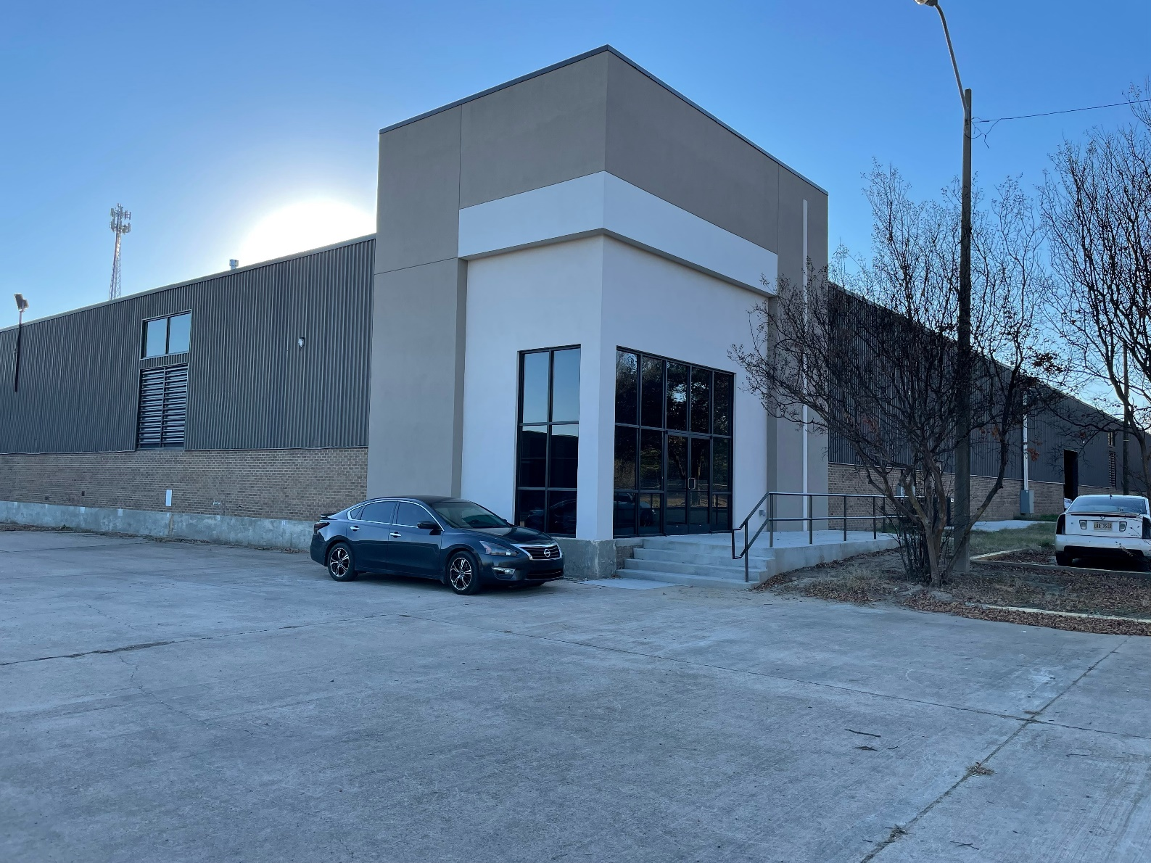

CEDS

2021 Update

2021 CEDS UPDATE

South Delta Planning and Development
District, Inc.

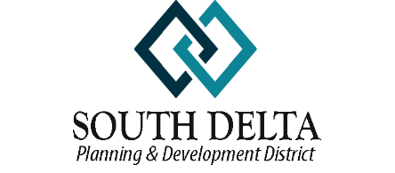

COMPREHENSIVE ECONOMIC
DEVELOPMENT STRATEGY UPDATE

FOR THE
SOUTH DELTA PLANNING AND DEVELOPMENT DISTRICT, INC.

COUNTIES

BOLIVAR SHARKEY
HUMPHREYS SUNFLOWER
ISSAQUENA WASHINGTON

December 1, 2021

PREPARED BY
South Delta Planning and Development District, Inc.
1427 South Main Street, Suite 147, Greenville, MS 38702

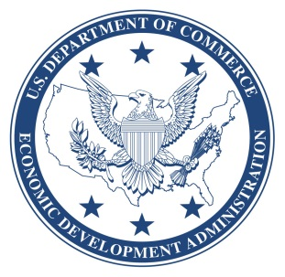

The preparation of this report was made possible by a grant from the U. S. Department of
Commerce, Economic Development Administration.

Update

The general demographic estimates of the region have not yet been thoroughly updated through the data collection and dissemination process of the 2020 decennial census. At this point, only the redistricting population numbers are available. Therefore, this update, will provide minimal demographic information and will mainly focus on changes in economic development activities, strategic projects, programs, activities, and the overall economy in times of a continuing pandemic.

This year has been very much like 2020 with regard to the economy, tumultuous at best. The changes in administration along with the ongoing COVID-19 Pandemic and all of the uncertainty arising from the different variants, continues to wreak havoc on the local, state, regional, national, and global economy. In addition to COVID-19, Mother Nature continues to brutalize some portions of the South Delta area. Flooding occurred once again in the south delta. Although, the flooding was not as widespread as in the previous two years, it appears that this annual occurrence will not be alleviated in the foreseeable future due to the actions of the Environmental Protection Agency. The actions of the EPA will not only continue to adversely impact the agricultural economy of the lower half of the South Delta District, it will also continue to drive population away from this same area. As noted in the following chart the trend of declining population has become critical in the South Delta District, especially in the 3 southern counties most regularly impacted by flooding.

The 2019 - 2021 flooding severely impacted all types of infrastructure in the District. In areas along the river that suffer with high water, sand boils and ground water seepage, underground infrastructure was severely impacted. Most notably, the City of Greenville’s waste water treatment plant was rendered inoperable causing environmental issues that were addressed as an emergency. Unfortunately, Greenville’s waste water treatment plant was just the tip of the iceberg, the flood had a major impact on many areas of the overall waste water transportation system. Addressing these issues based on their relationship to industry in the area was of particular urgency and an application for EDA’s FY 2019 Disaster Supplemental was submitted in early 2020. Fortunately, the City of Greenville was successful and was awarded EDA funding to address the waste water system in some of the most critical industrial areas of the City. Additionally, the District has assisted both the City of Greenville and Washington County in efforts to obtain Community Development Block Grant funding to address infrastructure issues in residential areas. All of the proposed system rehabilitation is being designed to increase the City’s resilience when flood conditions come around again.

Obviously, the annual flooding issues combined with the economic hardships of the COVID-19 pandemic have been devastating to the overall economy of the region. The main sources of employment and income in Humphreys, Issaquena and Sharkey counties is agriculture and agricultural support businesses. A large portion of the workforce in these counties found themselves without employment when the flooding persisted for months in 2019 and repeated in 2020 and 2021. A number of avenues were being investigated in an effort to move some of the displaced workers into employment that was not totally dependent on agriculture only to be faced with an overflow of labor displaced by the pandemic.

Sadly, the assumption that the flooding of 2019 and the early stages of the COVID-19 pandemic in 2020 would be the worst things to occur has proved incorrect. Early in 2020 the COVID-19 pandemic became the next big economic pitfall for not just the region but the globe. The almost complete shutdown of the economy locally and globally in March of 2020 took a toll on people and businesses everywhere. Both large and small businesses were adversely impacted by shutdowns of varying length and severity. Manufacturing entities, even those considered essential, were struggling to obtain raw materials and keep a full workforce. Small businesses such as restaurants, “mom and pop” retail, and service businesses were struggling more than the larger businesses. At the time of the March 2020 shutdown it seemed as if the negative impacts would not last too far into 2021. Once again assumptions based on the information available were incorrect. Shut downs and COVID protocols have lasted much longer than anticipated throughout the Country. Even though some states, Mississippi included, have ended the government mandated shut downs, a number of local governments and private businesses have chosen to continue the safety protocols. “Normal” and “business as usual” are concepts that seem to be a moving target making it that much more difficult to stabilize and grow the economy.

In an effort to continue to assist our local citizenry and business community, South Delta has chosen to participate in as many programs directed toward COVID-19 pandemic relief and recovery as possible, specifically the Coronavirus Aid, Relief, and Economic Security Act (CARES Act). The District has also encouraged, supported and assisted our member governments in the pursuit of funding through the other Coronavirus relief opportunities that have become available through the course of this year, including, but not limited to, the American Rescue Plan Act of 2021 (ARPA), the Build Back Better Initiative and the more recent bipartisan infrastructure law.

Included in these efforts were opportunities offered by the State of Mississippi from its allocation of CARES funds, as well as, direct program funding from the Economic Development Administration. Other funding agencies that did not have additional funding to offer used Coronavirus Response as a priority factor in determining grant awards for their regular competitive programs.

The District was fortunate enough to receive additional Partnership Planning dollars, for a two-year period, to provide the following to member governments:
- Short-term and long-term economic planning and coordination to update a disaster recovery and resiliency economic development plan.
- Technical Assistance and capacity building for member organizations, local businesses, and other local stakeholders impacted by coronavirus.

The District was also fortunate enough to receive funding to establish a new EDA Revolving Loan Fund for the purpose of assisting businesses that needed financial assistance to survive the COVID-19 pandemic.

As soon as these two programs were funded the District went to work implementing the Scope of Work for each. The Revolving Loan Fund provided working capital loans of $75,000 or less to approximately 29 approved borrowers. These working capital loans have helped these small businesses, spread throughout the region, stay afloat and remain viable, keeping their employees from the ranks of the unemployed.

The additional Partnership Planning dollars continue to allow the Community Development staff of South Delta to provide more technical assistance, funding research, grant writing, administration and planning for improved recovery and resilience to our member governments. During 2021, the Community Development staff has assisted with the preparation of 2 Delta Regional Authority applications and 5 Community Development Block Grant applications. Four of the Community Development Block Grant Applications are pending approval from the Mississippi Development Authority. All of these projects are consistent with the current Comprehensive Economic Development Strategy (CEDS) or are included in this update and will be included in the next CEDS rewrite.

The District is currently aiding a number of member governments that have received ARPA allocations. The District has signed agreements to either develop a grant program for counties to properly grant funds to water or utility districts or guide the process of obtaining lost revenue funds and expending the ARPA funds on eligible activities.

There are a number of projects that are still in the development phase that, even though they will not necessarily take advantage of any of the Coronavirus relief funding, will have a very positive impact on the recovery and resilience of the local economy when they come to fruition. Included in this is the regional project to renovate the hangars located at the Greenville Mid-Delta Airport. The intent of this project is to bring the existing hangars up to an acceptable standard for use by a maintenance, repair and overhaul company.

STRATEGIC PROJECTS, PROGRAMS AND ACTIVITIES

The following is a list of potential, ongoing and recently completed projects. These projects are based on the overall goals and objectives set forth in the Comprehensive Economic Development Strategy or they are included as a result of the economic issues brought on by the COVID-19 pandemic. The list includes very specific projects of a regional nature as well as rather broad projects based on the desires of individual communities. Some of the activities listed are in the beginning stages of implementation while others are still in the very early planning and development stage. Regardless of their status or range of benefit, all of these projects are important in one way or another to the South Delta Planning and Development District and its citizens.

Funding for these projects could come from any number of sources including Federal, state and local funds. Private sector investment will be essential for the success of some of these larger projects. Federal sources may include but, are not limited to, Delta Regional Authority, Economic Development Administration, USDA Rural Development, HUD, Federal Highway Administration and the Environmental Protection Agency. State funds may come from the Mississippi Development Authority, Mississippi Emergency Management Agency, MS Department of Health, MS Department of Environmental Quality and the MS Department of Transportation.

 |  | Strategic Project, Program or Activity |  | Responsible  Partners |  | Potential  Funding |  | Job Creation Estimate
Regional
Funded |  | Greenville Highway 82 By-pass |  | MDOT |  | MDOT,  USDOT
Vital |  | Design of I-69 Connectors |  | Bolivar County  Washington Co. |  | Federal  State  Local |  | 100+
Vital |  | Rebuild Railroad connecting Bolivar Co. to Washington Co. |  | Bolivar County  Washington Co. |  | Federal  State |  | 50+
 |  | Reopen rail service to the east side of the State |  |  |  | Federal  State  Private
Vital |  | Repurpose Greenville Airbase Facilities |  | Greenville |  | Private  Federal  State |  | 250
Ongoing |  | Brownfields Assessments and Clean-up as Needed |  | SDPDD |  | Federal  State  Private  Local
 |  | Establishment of Revolving Loan Fund for Historic and/or Brownfield Properties |  | SDPDD Area |  | Federal  State  Local
 |  | Construction of I-69 Corridor |  | Federal Highway |  | Federal |  | 100-500
Ongoing |  | Completion of Mississippi Blues Trail |  | MS Blues Commission |  | State
Develop-  ment |  | Expand Law Enforcement Training Facility MS Delta Community College |  | MS Delta Community College |  | Federal  State |  | 60 – 90/yr.
 |  | Open development ready land at the Port of Greenville |  | Greenville  Washington Co.  Port Commission |  | State  Federal |  | 25-100
 |  | Create alternate public port terminal at the Port of Greenville |  | Greenville Washington County Port |  | Federal |  | Disaster Relief
 |  | Open development ready land at the Port of Rosedale |  | Bolivar County  Port Commission |  | State  Federal
Bolivar County
 |  | Recreational Improvements All County Parks |  | Bolivar County |  | State
 |  | Owner Occupied Housing Rehabilitation |  | Bolivar County |  | State
Benoit |  | Sanitary Sewer System Improvements |  | Benoit |  | State  Local
 |  | Construction of Town Maintenance Facility |  | Benoit |  | Local
Beulah |  | Construction of new Town Hall/Fire Station - Completed |  | Beulah |  | Local  State
 |  | Water System Improvements –  Completed |  | Beulah |  | State
 |  | Owner Occupied Housing Rehabilitation - Ongoing |  | Beulah |  | State
Cleveland |  | Water Well/Baxter Healthcare Expansion – Funded |  | Cleveland |  | Local  State  Federal
Merigold |  | Owner Occupied Housing Rehabilitation |  | Merigold |  | State
 |  | Downtown Development |  | Merigold |  | Local  State
Mound Bayou |  | ADA upgrades and repairs to City Hall |  | Mound Bayou |  | Local  State
 | Owner Occupied Housing Rehabilitation |  |  |  | Mound Bayou | State
 | Downtown Development |  |  |  | Mound Bayou | State  Local
 | Water System Improvements |  |  |  | Mound Bayou | State  Local
Boyle | Owner Occupied Housing Rehabilitation - Ongoing |  |  |  | Boyle | State
Pace | Water & Sewer System Improvements |  |  |  | Pace | State
 | Renovate vacant school building for multi-purpose use |  |  |  | Pace  Bolivar County | State  Local
Renova | Construction of Public Park & Playground |  |  |  | Renova | State  Local
Rosedale | Owner Occupied Housing Rehabilitation - Ongoing |  |  |  | Rosedale | State
Funded | Sewer System Improvements |  |  |  | Rosedale | State
 | Water System Improvements |  |  |  | Rosedale | State
 | Drainage System Improvements |  |  |  | Rosedale | State
 | Construction of a Community Facility Building |  |  |  | Rosedale | State  Local
 | Rehabilitation of Public Parks |  |  |  | Rosedale | State  Local
Shaw | Wastewater Treatment Facility Improvements |  |  |  | Shaw | State  Federal
 | African American History Recording  Completed |  |  |  | Shaw | Federal
 | Downtown Improvements (Sidewalks and Lighting) |  |  |  | Shaw | State  Local
Shelby | Industrial Facility Renovations |  |  |  | Shelby  Bolivar County | State  Federal
Completed | Water System Improvements |  |  |  | Shelby | Federal  State
 | Downtown Improvements (Sidewalks and Lighting) |  |  |  | Shelby | State  Local
Winstonville | Sanitary Sewer System Improvements |  |  |  | Winstonville | State  Federal
 | Construction of a Multi-purpose Building |  |  |  | Winstonville | State  Local
Humphreys Co.
 | Construction of Health and Human Services Complex - Completed |  |  |  | Humphreys County | State  Federal  Local |  | 10-25
 | Basketball Court Construction/Park Renovations |  |  |  | Humphreys  County | State  Local  Federal
 | Owner Occupied Housing Rehabilitation - Ongoing |  |  |  | Humphreys  County | State
Pending | Drainage Improvements |  |  |  | Humphreys  County | State
Belzoni | Improve Public Tennis Courts |  |  |  | Belzoni | State  Federal  Local
 | Drainage Improvements |  |  |  | Belzoni | State  Federal  Local
 | Water/Sewer System Improvements |  |  |  | Belzoni | State  Federal
Louise | Downtown Improvements |  |  |  | Louise | State  Federal
 | Renovate Town Hall |  |  |  | Louise | State  Local
 | Owner Occupied Housing Rehabilitation |  |  |  | Louise | State
Issaquena County | ADA Compliance of Courthouse  Complete |  |  |  | Issaquena County | State Federal
 | Provide Water to Unserved Areas |  |  |  | Issaquena County | State  Federal
 | Construct Additions to County Courthouse |  |  |  | Issaquena  County | State  Local
 | Construct Multi-Purpose Facility |  |  |  | Issaquena County | State  Local
Mayersville | Owner Occupied Housing Rehabilitation |  |  |  | Mayersville | State
Completed |  | Sanitary Sewer System Improvements |  |  | Mayersville | State
Sharkey County |  | Construct Drainage Improvements |  |  | Sharkey County | State  Local
 |  | Industrial Facility Expansion |  |  | Sharkey County | Federal  State
Anguilla |  | Owner Occupied Housing Rehabilitation |  |  | Anguilla | State
 |  | Construction of a Multi-Purpose Facility |  |  | Anguilla | State  Local
 |  | Extend Water System to Unserved Area |  |  | Anguilla | State  Federal
Rolling Fork |  | Water System Improvements |  |  | Rolling Fork | State  Federal
 |  | Sanitary Sewer System Improvements |  |  | Rolling Fork | State  Federal
Pending |  | Drainage Improvements Phase II |  |  | Rolling Fork | State  Federal
 |  | Renovate Public Swimming Pool |  |  | Rolling Fork | Local  Federal
Sunflower County
 |  | Industrial Building Renovation - Ongoing |  |  | Sunflower  County | Local  State | 20 Jobs
 |  | Street and Drainage Improvements Ongoing |  |  | Sunflower County | Local  State
 |  | Owner Occupied Housing Rehabilitation |  |  | Sunflower  County | State
 |  | Airport Access Road Improvements |  |  | Sunflower  County | State  Federal
Drew |  | Sewer System Improvements  Completed |  |  | Drew | State
 |  | Owner Occupied Housing Rehabilitation |  |  | Drew | State
Indianola |  | Owner Occupied Housing Rehabilitation - Ongoing |  |  | Indianola | State
 |  | Construct Fire Station |  |  | Indianola | State Federal
 |  | Renovation of Neighborhood Parks |  |  | Indianola | Local
 |  | Sewer System Improvements  Complete |  |  | Indianola | State  Local
Inverness |  | Purchase Equipment for Fire Department Completed |  |  | Inverness | State
 |  | Construct Fire Station - Completed |  |  | Inverness | Federal
 |  | Owner Occupied Housing Rehabilitation |  |  | Inverness | State
 |  | Street Improvements |  |  | Inverness | State  Local
 |  | Sewer System Improvements |  |  | Inverness | State  Federal
Moorhead |  | Purchase Three Police Cars |  |  | Moorhead | Federal
 |  | Construct Wellness Facility –  Complete |  |  | Moorhead | State Federal  Local
 |  | Street and Drainage Improvements |  |  | Moorhead | State  Federal
 |  | Owner Occupied Housing Rehabilitation - Ongoing |  |  | Moorhead | State
 |  | Sewer System Improvements  Completed |  |  | Moorhead | State  Federal
 |  | Construct Walking Track  Phase I Complete |  |  | Moorhead | State  Federal  Local
Ruleville |  | Street Improvements |  |  | Ruleville | State  Federal
 |  | Owner Occupied Housing Rehabilitation |  |  | Ruleville | State
 |  | Sewer System Improvements |  |  | Ruleville | State  Local
Sunflower |  | Street Improvements |  |  | Sunflower | State  Federal
 |  | Construct Community Facility Building |  |  | Sunflower | State  Federal
 |  | Owner Occupied Housing Rehabilitation - Ongoing |  |  | Sunflower | State
 |  | Sewer & Water System Improvements – Completed |  |  | Sunflower | State  Federal  Local
 | Downtown Improvements (Sidewalks and Lighting) |  |  |  | Sunflower | State  Local
Washington Co.
 |  |  | Renovate Buildings for Economic Development Purposes |  | Washington  County | State  Local  Federal
 |  |  | Construct Multi-Family Housing  Complete |  | Washington  County | State  Federal
 |  |  | Construct Sheriff’s Department Training Facility |  | Washington County | Federal State
Arcola |  |  | Downtown Improvements (Sidewalks and Lighting) |  | Arcola | State  Local
 |  |  | Construct Indoor Recreation Facility |  | Arcola | State  Local
 |  |  | Water System Improvements |  | Arcola | State  Federal
 |  |  | Owner Occupied Housing Rehabilitation - Ongoing |  | Arcola | State
 |  |  | Renovate Public Bldg. For Community Resource Center |  | Arcola | State  Local
Greenville |  |  | Rehabilitate Historic Area of Downtown |  | Greenville | State  Local  Federal | 25-100
 |  |  | Neighborhood Park Improvements |  | Greenville | State  Local
 |  |  | Reconstruction of Major Traffic Arteries |  | Greenville | State
 |  |  | Construction of new Federal Courthouse Building – Rebid Required |  | Greenville | Federal
 |  |  | Sanitary Sewer System Improvements - Ongoing |  | Greenville | Federal  State  Local | Disaster Relief
 |  |  | Move Downtown Greenspace from Steinmart Square |  | Greenville | Local
Hollandale |  |  | Purchase Equipment for Fire Department |  | Hollandale | State  Federal
 |  |  | Street Improvements |  | Hollandale | Federal  State
 |  |  | Water System Improvements  Complete |  | Hollandale | Federal
 |  |  | Sewer System Improvements  Complete |  | Hollandale | Federal  State
Leland |  |  | Owner Occupied Housing Rehabilitation - Ongoing |  | Leland | State
 |  |  | Water System Improvements  Complete |  | Leland | Local  Federal

ACTION PLAN

Design of I-69 Connectors |  | Construction costs  unknown – location to be established |  | Strategic Finding- Transportation Improvement for Easier Access | Feasibility Study and Environmental Study Phase
The City of Greenville has commissioned studies for the purpose of reviewing alternate routes to I-69. Upon finalization of route selection, South Delta will assist in obtaining funding for the construction of the connector.
Rebuild Rail from Bolivar Co. To Washington County |  | $25,000,000 - $35,000,000 |  | Strategic Finding-  Transportation Improvement for Easier Access | Seeking Funding – CRISI Application Submitted
Bolivar County and the Port Commission, owners of the railroad, are working with a short-line rail operator to implement a plan to rehabilitate the rail and reestablish service. South Delta has made initial contact with potential funding sources.
Establish RLF COVID-19 relief, response, and recovery |  | $2,000,000 |  | Strategic Finding-Enhanced Quality of Place, Employment Opportunity | Funded – Initial Loan Out Complete
South Delta obtained funding from EDA through the CARES Act of 2020.
Repair of Greenville’s Sewer System |  | $17,000,000 |  | Strategic Finding-Infrastructure | Funded – Ongoing
Delta Strong | Non-Construction |  | Strategic Finding- ED Rebranding and Marketing |  |  | Ongoing
Regional eighteen-county effort.
Port Expansions – Greenville & Rosedale | Unknown at this time. |  | Strategic Finding-  Transportation/Industrial
South Delta has previously submitted applications for funding the Greenville Port Expansion. Port at Rosedale is still in the planning stages.
Rehabilitation of Existing Hangars – Greenville/Mid-Delta Regional Airport – Hangar 450 | $28,000,000 Total Depot Level  $15,000,000 |  | Strategic Finding-Infrastructure |  |  | Local Funding Pending – Lease Under Negotiation
South Delta is working with local officials and EDA to fund Hangars 448, 449, and 173. Hangar 450 will create approximately 200 jobs. Attaining Depot Level status will increase job creation to 650.
Complete Street – City of Greenville in support of new Federal Courthouse Project | $5,000,000 - $10,000,000 |  | Strategic Finding: Quality of Place Improvements

As indicators change, the CEDS will need to be flexible and adjustable. Elimination of some problems will allow other problems to move up the priority list. As goals are reached, new goals must be established. Although goals are accomplished, the aim of this plan will not be reached until “the bottom is at the top”. Success will be measured in “degrees of accomplishment, not by the elimination of goals”.
It is a basic axiom in sociology that one’s interests determine one’s ideologies. The Delta is no exception. Economic and social interests play a large part in perceptions of economic development, with each group proposing models that are supportive of its own perceived interests.
Despite these differences, there are also commonalities. All groups list economic development as a major priority, feel that interracial communication is important in achieving this goal, and that this communication has improved. A number of models of development are needed for a region like the Delta. However, the actualization of any type of development needs planning and communication to enhance the process. A commitment to economic development and recognition of the need for interracial communication exists among all leadership groups. These commonalities represent the hope of the future for this region.

